RE 371 Notes

National Park Service Mission:

- Single use
- Limit the abuse of further explorations
- Remove from public domain
- Preserve lands that exhibit special values
- Maintain lands for the purpose of educations
- Preserves lands for the future generations

National Park Service Information:

- 13% of all federal land
- 84 million acres
- Antiquities Act 1906 lead to the development of national monuments.

Reclamation Act 1902:

- Development of dry land areas
- Creating Irrigation
- Drinking waters
- Electricity production

Significance of the 100th Meridian

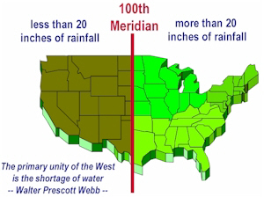
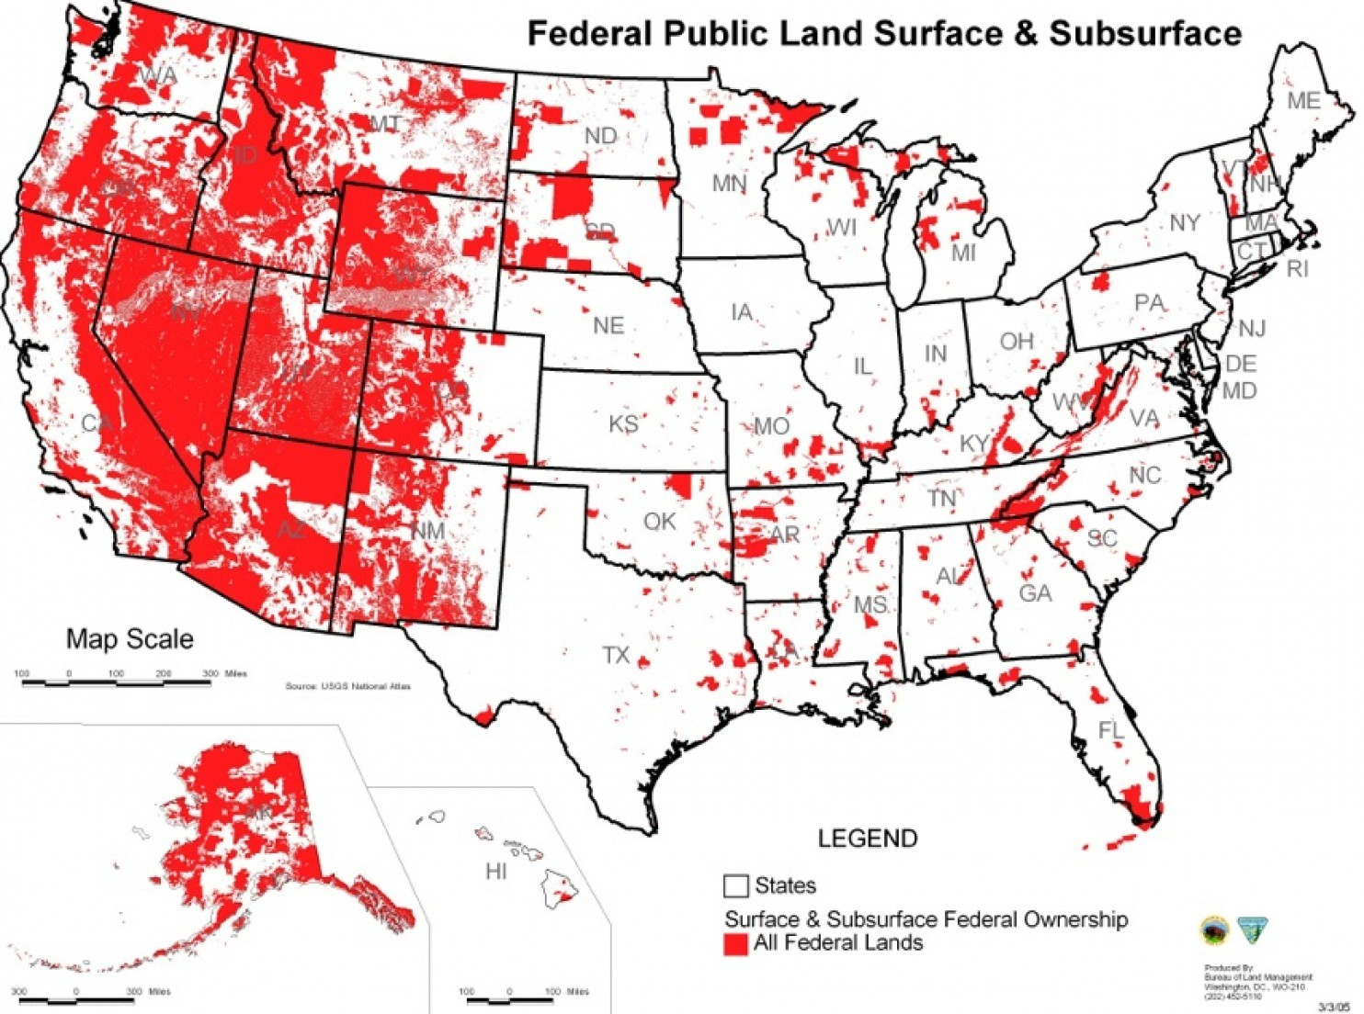

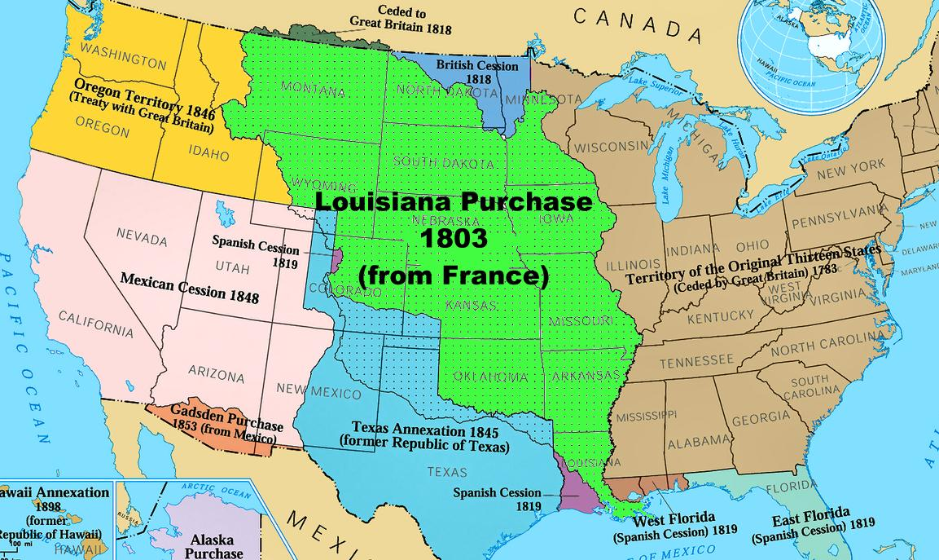
- John Wesley Powel Father of Reclamation (Nations 1st Raft Guide)
- Reclamation of the Colorado River 1867
- Pat Garrett, NM Water Company
- Trukee Irrigation Project
  - Francis Newland (Nevada Sate Representative)
  - Failure
- Federal Involvement in Reclamation
- Desert Waters Act 1877
- Homestead Act
Reminder of the History:

Public Domain
Federal Domain:
- US Owns 28% of land
- 640 Million Acres
Yellowstone National Park 1872
- Set aside Public Park, or pleasuring ground for the benefit and enjoyment of the people
Antiquities Act 1906
- Preservation of native culture
Park Service 1916
- Preservation and Education
Single-Use v Multiple-Use
- Single Use: Preservation
- US National Park Service
US Departments of Fish and Wildlife

Single-Use
- 8% of US lands are federally managed
- National Park Service 1916
- Entertainment of visitors (Yosemite Fire-Fall)
Public Law 1978: Bring the attention to preservation
- Note of Recreation Saturation Points (carrying capacities)
- Maximum point of the highest type of recreation use that a wilderness can receive.

Early Preservation
Arthur Carhart & Aldo Leoopold
- Arthur was a US Forest Service official, writer and conservationist who inspired wilderness protection in the United States
- First Designated Wilderness Preserves
- Research Reserves – Experimental Station
Robert (BOB) Marshall
- Wilderness Society
- Direct intervention with the government for protection
Sierra Club
- Lobby for preservation
- Certification of outdoorsmen

The Wilderness Acts
Public Law 88 577: The 1964 Wilderness Act
- Wilderness defined: “Untrammeled by man”
- People can go, but are considered visitors
- Management was to decrease destruction of these wilderness areas

Eastern Wilderness Act 1975
- Added Wilderness areas east of the 100th Meridian

Federal Land Policy and Management act of 1976
- BLM set aside 8% of it’s managed lands as wilderness
Alaskan Wilderness Mid 1980’s
- Addition of 700 acres to the Wilderness Preservation System

Wilderness Preservation

- NPS & FWS Single Use
- USFS & BLM Multiple Use
- The Wilderness Acts bind these organizations
- Preservation for today and the future
- Development of Direct values
“The purpose of the Wilderness Act is to preserve the wilderness character of the areas to be included in the wilderness system, not to establish any particular use.” — Howard Zahniser, 1962

Principles of Wilderness Preservation
- The wilderness lands that are protected are areas of public lands
- Congress designates selected portions of national forests, parks, wildlife refuges, and other public lands
- Human influences are restricted in wilderness units, so that nature can change as it will
- Wilderness areas serve multiple uses consistent with the Wilderness Act mandate to preserve the character of the area including watershed, agriculture, and endangered species.
- They are a resource for diverse types of outdoor recreation activities so long as activates are not motorized or do not make use of mechanical vehicles or equipment.
Pinchot Institute
- Oversight of Federal Wilderness
- Lands managed as a system
- Stewardship is the best policy for management
- Regulate human use of wilderness to preserve the quality, character, and integrity so that wilderness remains undisturbed for centuries.
Pinchot Institute Principles

- Make a strong commitment on wilderness stewardship before wilderness is lost
- Organize and maximize stewardship effectiveness and develop a fully integrated stewardship system across the wilderness systems
- Accelerate the planning and prepare plans for guidance of stewardship activities, enhance opportunities for evaluation and accountability and increase the probability that the wilderness system will be maintained
- Enhance science, education, and training programs to provide information, professional expertise, and public support for wilderness stewardship
- Create wilderness stewardship positions as career opportunities from top to bottom and deploy financial resources for explicit stewardship and support of wilderness
- Embrace the maintenance and sustainability of the wilderness system.

Multiple-Use Policy
- NFS
- BLM
  - Many activities are allowed on federal properties
- Multiple-Use Sustained Act of 1960
  - National Forests shall be administrated for the use of outdoor recreation, range, timber, watershed, and wildlife preserve.
- Management of rentable surface resources
- Sustained Yield
  - Achievement and maintenance in perpetuity (last forever) of a high-level output of natural resources
- Public Law 94 579 Federal Public Land Policy Act (1976)
  - Certain areas of the BLM became Wilderness Preservation Systems
  - Sustainable yields principles
Outdoor Recreation Resource Review Commission (ORRRC)

- Established by President Eisenhower in 1958

- 1962 classification of resources

ORRRC Land Calcification:

- High Density Recreation Areas
Facilities:
- Large investments
- Many facilities
- Permanent structures
Use:
- Exclusively used for recreation
- High weekend use
Land Use:
- Near urban areas
- Competes with other types of development
Examples:
- Beaches, Boardwalks, Swimming Pools, Tourist Park

- General Outdoor Recreation Areas
Facilities:
- Few built areas
Use:
- Weekend
- Vacation
Land Use:
- Competes with a variety of uses; urban and rural
Examples:
- Campsites, Picnic areas, Ski areas, etc.

- Natural Environment Areas
Facilities:
- Few
- Simple
- Users enjoy the natural features
- Access roads, trails, primitive camping, fire rings are established
Use:
- Dispersed
- Hunting and Fishing
Land Use:
- Small area
- Special use
Example:
- BLM
- USFS
- State
- Boundaries of NPS

- Unique Environment Areas
Facilities:
- Few
- Acceptable only
- Enhanced protection
Use:
- Limited to observation
Land Use
- Small area
- Special use
Examples:
- Old Faithful geyser
- Primitive Areas
Facilities:
- None except for trails
- No modern structures
- No machine
Use:
- Solitude
- Commercial use is prohibited
- Preservation
Land Use
- Competes with multi-use
- Ranching, Mining
Examples:
- Porcupine Mountain State Park
- Pecos Wilderness, NM

- Historic and Cultural Sites
Facilities:
- Emphasis on restoration
- Historic features
Use:
- Varies depending on the natural resource
Land Use
- Appreciation and Preservation only
Examples:
- Mt Vernon, VA
- Mesa Verde

How Does The Government Acquire Lands

Transfer of Land Rights
- Person deeds land to a government
- Deeded for public use
- Local: Longyear properties

Escheat
- Property goes to the state after death
- No heirs
Forfeiture
- Criminal action
- State can seize property

Land Exchange
- The USDA can exchange a parcel of land for another
- Public Law 114-38 – Being able to trade properties if it improves the federal land

Eminent Domain
- A power of the government to take private land for public use
  - For the good of the public: in the best of public’s interest
- US Fifth Amendment “Taking Clause”
  - No private property shall be taken for public use without just compensation
- Just Compensation
  - Must be paid fair market value
  - Government official cannot take land for his or her own use
  - Potential impact on adjoining property

Process of Eminent Domain
- Government determines a need
- Government makes an offer
- Fair market value
- May or may not accept
- Fee Title Purchase
- Scenic Easement
- Condemnation
- Inverse Condemnation

Leave No Trace

Leave No Trace Mission: To promote and inspire responsible outdoor recreation through education, research, and partnerships.

- Plan Ahead & Prepare
- Travel & Camp on Durable Surfaces
- Dispose of Waste Properly
- Leave What You Find
- Minimize Campfire Impact
- Respect Wildlife
- Be Considerate to Others

Program Roots
- Backcountry and Federal designated wilderness
- Successful at targeting back and front country campsites

Conception & Early Development
- Federal agencies developed educational brochures in the 1970’s
- Slogan Based
- Various Names
- Wilderness Manners
- Wilderness Ethics
- Minimal Impact Camping
- No Trace Camping

The “No-Trace” Program
- Developed by USFS wilderness managers in the early 1980’s
- Humanistic approach for wilderness ethics and low impact hiking & camping

Leave No Trace Name Selected In: 1990

Partnership Structure:
- Federal agency
- Corporate
- Local & State
- Non-Profit
- University & School
- Outfitters & Guides
- Retail
- International
- USFS – NPS – BLM – USFWS

Facts About BIO Diversity

The most diverse group of animals are invertebrates. They are animals that lack backbones, including insects, crustaceans, sponges, scorpions, and many other organisms. Over half of all the animals are identified as invertebrates.

Threats to Biodiversity

- Habitat loss / degradation
- Over exploitation
- Spread of non-native species / diseases
- Climate change
- Pollution

Evasive Species
- An exotic or alien species that has been introduced to a new area, which may or may have negative effect
- Key factor is a lack of predators to control the evasive species
  - Co-Evolution species
- Exploration of Resources
  - Salt Cedar

Where Do Invasive Species Come From?

- Rats in the Virgin Islands from ships; Mongoose control the rats
- Rabbits in Australia / Victoria Collage
- Deer and possum in New Zeeland
- Pigs
- Exotic Animals

Some Invasive Species in Lake Superior

- Sea Lamprey
- Zebra Mussels
- Rainbow Smelt

Purple Loostrife

Growth Form - Purple Loostrife is an herbaceous, wetland perennial that is capable of producing millions of seeds in a single growing season.

Impact - It can invade upland sites but has a preference for wetlands. Found it ponds, ditches, wet meadows, marshes, rivers, and lakes.

Over Exploitation

- Hunting
- Fishing
- Over Use

Licensure & Permitting

- Private / Commercial / Non-Profit Use
- National Outfitters Act
- Special Use Permits
- Different in every management region

