GWT - INTERPRETIVE PROGRAM COVERSHEET

Title of GWT: UP Trees That Don't Lose Leaves.

Interpreter’s Names: Evan Dunbar & Justin Ozrovitz
Date of Program: November 18, 2015
Location & Length of Program (time/distance):
Location - Black Rocks Cliff Area
Length - 30 minutes

Distance - Half a mile hike
Resource: Coniferous Trees on Presque Isle - Marquette Michigan
(Northern White Cedar, Red Pine, Balsam Fir, White Pine)

Interpretive Enhancement selected: Using Plant or Animal Identification Keys / Guides

Theme: Coniferous trees play a vital role in the ecosystem of Presque Isle in Marquette, Michigan.

Location of stop & name of interpreter leading stop:
1. Staging area: Parking Lot of “Black Rocks Cliff” – Evan Dunbar & Justin Ozrovitz
2. Introduction: Location: Picnic tables next to some cedar trees, just beside the parking lot – Justin Ozrovitz
3. Stop 1 - Cedar trees off to the right of the trail, next to the lake. – Justin Ozrovitz
Stop 2 - location - Evan Dunbar
Stop 3 - Balsam Fir batch along the trail, just prior to hitting the pavilion - Justin
Stop 4 - White pine near sunset point - Evan Dunbar
Stop 5- Sunset point picnic shelter- Evan Dunbar- White Pine Tea
Conclusion – Wooden pavilion next to “Sunset Point” parking lot – Justin & Evan

Starting Location - PEIF (1410 Presque Isle Ave)

- Turn RIGHT onto Presque Isle Ave at the intersection of Presque Isle Ave, and Summit St. head NORTH until you hit Hawley St. 0.8 miles
- Turn RIGHT onto Hawley St. 0.1 miles
- Turn LEFT onto N. Lakeshore Blvd 0.8 miles
- Continue onto Peter White Drive 0.2 miles
- Turn LEFT and stay on Peter White Drive 0.6 miles
- Continue down Peter White Drive, and start heading around the peninsula. Your destination will be a parking lot below a ridge about .8 miles into the peninsula.
- Make a sharp right turn into the “Black Rocks Cliff” parking lot at the green colored sign saying (UP Trees, That Don't Loose Leaves).
- Park in the parking lot and meet in front of the cove.
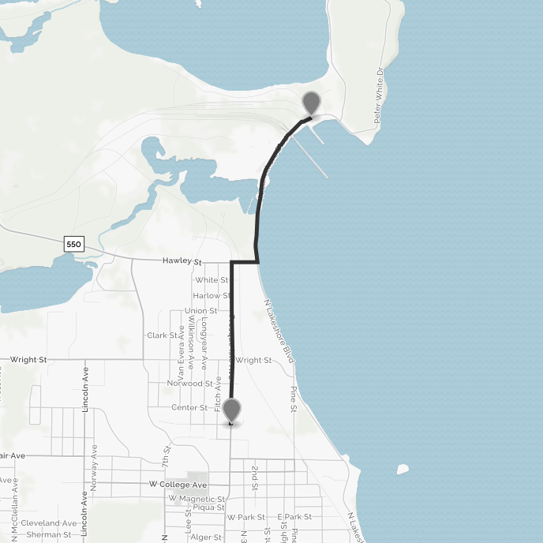
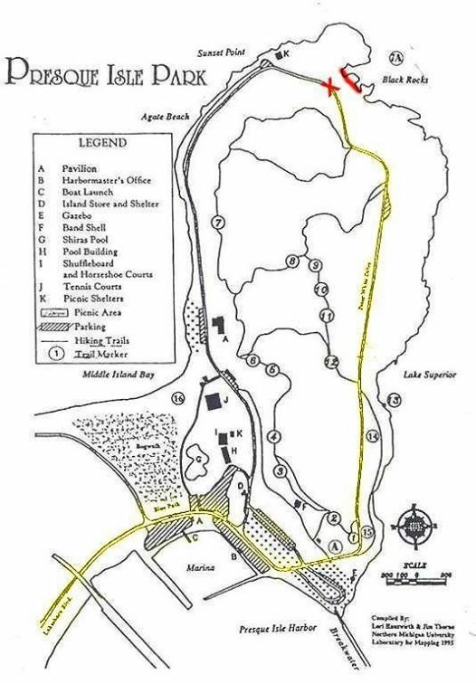

Guided Walk & Tour Planning Worksheet (GWT-PW)

1. Interpreter’s Names: Evan Dunbar & Justin Ozrovitz
2. Agency & Audience
a. Agency - Moosewood Nature Center
b. Mission of the Agency.
“To celebrate nature through education and action
in the Upper Peninsula.”

c. Description of Audience.
Our audience will be a mixture of both male and females, ranging from the ages of eighteen to the upper twenties. We are unsure of the prior knowledge our audience has on our topic; we can however assume that they will have some interest in it due to them all being ORLM students at NMU.
3. Organization of GWT
a. Topic - Coniferous trees in the Upper Peninsula.
b. Sub-Topic - Coniferous trees uses and abilities.
c. Focus: Natural Environment
d. Theme: Coniferous trees play a vital role in the ecosystem of Presque Isle in Marquette.
e. Purpose of the GWT - To increase the overall awareness of the impact native coniferous trees have on our local ecosystems.
f. Body of the GWT.
a. Staging Period: Location - Right in front of the black rocks cove, in the parking lot of black rocks cliff. People should be able to see us from the road up above if we’re standing there; just incase people are late and need to find us.
- Materials Needed - Backpack with essentials: First aid kit, Cell phone, Water, Food (sugar), Extra writing utensils.
b. Introduction: Location - Picnic tables at the east end of the parking lot, right before we enter the forest. People should also be able to see us from the road up above when at this location, just incase people are late and need to find us.

- Materials needed - Coniferous tree information booklets to hand out.

c. Stop 1- Northern White Cedar –
Location - Off the trail to the right of the introduction area (east side).
Materials needed - Picture Handouts & Coal
i. Focusing Statement:
- Thuja occidentalisis; also known as Northern White Cedar, & Eastern White Cedar is a very unique tree that has an effect on the local ecosystem of presque Isle
ii. Description:
- The Northern White Cedar
- The tree is native to Manitoba and east, throughout the Great Lakes region and into Ontario.
- Mature trees can reach heights of 40-50’, and can have trunk diameters of 1.5’
- The Northern White Cedar has fan-like branches and scaly leaves. (Pass out branch / needles)
- The bark is reddish-brown, furrowed, and peels in narrow, longitudinal strips.
- Most seeds drop from mid-September to late October, but some drop during winter.
- It grows naturally in wet forests, particularly abundant in coniferous swamps where other larger and faster-growing trees cannot compete successfully.
- Is home to the bluejay.
- USES:
  - Fencing and posts, lumber, shingles and in the construction of log cabins. (Rot Resistant)
  - White cedar is the preferred wood for the ribs and planking, of birchbark canoes
  - Others have used the twigs and leaves to make teas to relieve constipation and headache. (we will be having some one this after our talk)

iii. Thematic Connector
- It is NOT currently listed as endangered, However, populations are threatened in many areas by high deer numbers; the deer find the soft evergreen to be a very attractive winter food, and strip it rapidly. (Pass out photo). This “tree of life” keeps the local deer population on presque isle alive and strong.
- They are very succesfull growing on the edges of cliffs.
- The cedars reproduce by dropping seeds, which find small pockets of soil and moisture in the cracks and ledges of cliffs.
- The fungi and algae collect phosphorus and nitrogen from the rocks and transfer them to the tree roots, allowing them to grow.
- Their roots grab onto the rock formations helping with the prevention of erosion. This is key into keeping the cliffs intact on the peninsula. These trees do whatever it takes to stay alive.
- Acid rain caused by the local coal plants have greatly affected the local coniferous trees. Coal naturally contains sulfur, and when coal is burned, the sulfur combines with oxygen to form sulfur dioxide. When evaporated the SO2 mixes with the air molecules and creates acid rain. The acid rain that falls here on presque isle stunts the growth of trees; The rain dissolves the nutrients and helpful minerals in the soil and washes them away before trees can use them to grow.
- If you're interest in seeing an old growth forest that has NOT been affected by acid rain, you can visit Fayette State Park, located in the Garden Peninsula, on the lower end of the Upper Peninsula. This old growth of trees is on Limestone, which acts as a neutralizer to the acid rain.

iv. Transition
- Another coniferous tree native to Michigan that we have here on Presque Isle, is the Red Pine. Unlike the Northern White Cedar, this tree is not rot resistant. It does however grow in areas that are prone to erosion, including sandy soils. Therefore unlike other trees, this tree can also help with the erosion prevention on presque isle.

d. Stop 2- Red Pine - location, materials needed
i. Focusing Statement
- The Red Pine has had a significant impact
ii. Description /Explanation
- Mature Trees can range from 40-80’
- The needles are clustered, there is two needles per cluster. They are about 4-6” in length. (Pass Out Needles)
- The bark is reddish brown and becomes red higher up and grows in flat scales (Pass Out Bark)
- They can live up to 200 years old
- The red pine is the official state tree of minnesota.
- Red pines typically germinate after forest fires. Forest fires are essential to the regeneration because it prepares the seedbed by destroying competing plants and cone eating insects.
- Once the tree is established it is requires little to no care and can live up to 200 years old.
iii. Thematic connector
- The red pine has the unique ability to grow in incredibly sandy and dry soils. It grows where other trees won't.
- The tree is commonly used as timber and many of the red pines (as well as the white pines) in the area were cut down. Today it still plays a large role in the timber industry in last year alone the Michigan DNR made $5.6million on just red pine.
- The tree is also called the norway pine because settlers commonly confused it with the Norway Spruce of europe.
- Red pine stands are also aesthetically appealing because very little grows under them. For example out at little presque there is a very large stand of red pine that has very little growing under it this is because of the high acid content in the needles and its ability to block out light.
- Whorl Activity The age of a pine tree can be determined by counting the number of “whorls”. The branches of a pine tree all grow outward from the perimeter of the trunk at one particular location annually. This is a called a whorl. There are stretches of no branches in between the whorls. A growing pine tree adds another whorl of branches each year. To determine the age of a pine tree simply count the whorls of branches from the bottom to the top of the tree. Near the bottom of the tree the branches may be completely broken off and you will need to find the knots on the trunk where the branches broke off in order to be able to count all the whorls. Then add approximately 3-5 years to account for when the seedling was so small that there is no evidence remaining of its branches.
- Deer, cottontails, and snowshoe hares browse songbirds, mice and chipmunks feed on the seed while seedlings.
iv. Transition
- The red pine has played a huge role in the Upper Peninsula timber industry and was played a huge role in the economization of the Upper Peninsula.

e. Stop 3 – Balsam Fir - location, materials needed
i. Focusing Statement:
- The Balsam Fir also known as Abies Balsamea, is beneficial to the diverse animals and ecosystem here on Presque Isle.
ii. Description:
- Full grown these trees can stand 40-60’
- Trunk Diameter of 1.5’
- Growth is optimum in areas with a average temperature 35° to 40° F (Marquette is perfect for this weather)
- Habitat - moist soils that are well-drained & shaded forests.
- Balsam fir has been reported as growing on soils of a wide range of acidity.
- The balsam fir has tiny resin blisters which are filled with resin, also referred to as Canadian Balsam, hence why the name of the tree is Balsam Fir.

iii. Thematic connector
- Balsam Fir is the most popular Christmas Tree, mainly due to it’s ability to hold up the heavy snow very well.
- White tailed deer like to rub their antlers on the balsam firs bark due to it’s softness. They do this to remove the velvet from their antlers, and/or to mark a sent for mating.
- Deer, moose, rabbits, and many species of birds use the balsam fir tree for thermal cover, the dense foliage of this tree cuts down on wind and insulates the area.
- The thick foliage also stops the snow before it hits the ground, making it easier for animals to move around or evade predator.
- Deer however don’t like the taste of this tree, unlike the Northern White Cedar which they eat a great deal of.
- Red squirrels feed on the seeds, bark. which are located at the very top of the tree, usually within the top 3 feet.
- Black bears strip the bark and find the wood underneath to be a pleasant snack.

iv. Transition

- Let’s now head over to our next coniferous tree which is the White Pine. Evan will cover this one.

f. Stop 4 – White Pine - location, materials needed
i. Focusing Statement
- The White Pine, Michigan's State Tree, has played a significant role in the colonization of the upper peninsula

ii. Description
- In natural precolonial forests they can get up to 230 feet tall (The height of three ore docks stacked on top of eachother.
- Mature trees can easily be 200-250 years old but some reach up to 500 years old
- The diameter can range from 3.3-5.5 feet in mature trees
- Uses
  - Timber:The wood is readily available and is a commonly used building material. It typically grows very tall and straight making it ideal for building timbers.
  - Wildlife: Deer, mice, gray and red squirrels have been known to eat the seeds
  - Erosion: It is commonly used as a windbreak on farms. It has the ability to grow in many soil types.

iii. Thematic connector
- The White pine has had a significant impact on the colonization of the upper peninsula
- The White and Red Pines of the Upper Peninsula were the most sought after tree during the logging era.
- The white pine has the ability to reach 230 feet tall making it the tallest conifer in the Upper Peninsula
- Due to its high value it was almostly entirely harvested during the big cut eras decimating existing stands
- According to the US Forest Service “White pine remains potentially the most economically and certainly the most ecologically valuable species in much of the region”
- White pines originally were used as masts and white pines were commonly called “Mast Pines”. There was actually a
- Today only 5% of the original white pine stands still contain white pine. A 95% reduction in population. Imagine what today's forests would have looked like.
iv. Transition
- The white pine was the single most valued tree during the logging era and today white pines make up a small portion of the forests in the upper peninsula.

g. Conclusion –
- At the end of the trail there is a nice sized pavilion where we will debrief with the group. We will do this after passing out cedar tea to everyone that wants some.
- While the audience has some tea, we are giving them the opportunity to not only check out a display of branches from the four trees we covered, but two other local coniferous trees as well. This will allow people to ask us questions if they have, or to mingle freely with their classmates while enjoying some tea.
Materials Needed -
- Cups for tea.
- The tea itself, in a warming thermos.

h. Limitations: Both of us have traveled to our walks location twice now. We picked up trash and got the trail ready for our talk. We did not see any limitations that might interfere with us interpreting our theme. However, the wind noise and rain might make it a little uncomfortable for our audience; this is mentioned on our Risk and Safety worksheet.

4. Objectives
a. To have our audience members understand the many uses and abilities of a handful of coniferous trees in the Upper Peninsula’s ecosystem, by the end of our guided walk and tour.

b. Our entire audience will be able to identify 4 different coniferous trees native to the Upper Peninsula when asked to do so by the end of our guided walk and tour.

5. Accuracy - References

a. Topic references:

Leeson, Tom. Snowshoe Hare. N.d. N.p.

"Thuja Occidentalis - Eastern White Cedar." Thuja Occidentalis - Eastern White Cedar. N.p., n.d. Web. 13 Nov. 2015.

Fleming, Nick. "Plants Talk to Each Other Using an Internet of Fungus." BBC. N.p., 11 Nov. 2014. Web. 15 Nov. 2015.

"Forest Types: Balsam Fir." Forest Types: Balsam Fir. N.p., n.d. Web. 15 Nov. 2015.

"Effects of Acid Rain - Forests." Effects of Acid Rain. N.p., 4 Dec. 2012. Web. 15 Nov. 2015.

"SIMPLIFIED KEY TO CONIFER GENERA OF THE UNITED STATES." SIMPLIFIED KEY TO CONIFER GENERA OF THE UNITED STATES. N.p., n.d. Web. 17 Nov. 2015.

b. Interpretive Process References:
Brochu, Lisa, and Tim Merriman. Personal Interpretation: Connecting Your Audience to Heritage Resources. Fort Collins, Colo.?: InterpPress, 2002. 50-52. Print.

Brochu, Lisa, and Tim Merriman. Personal Interpretation: Connecting Your Audience to Heritage Resources. Fort Collins, Colo.?: InterpPress, 2008. 55+. Print.

Ham, Sam H. Interpretation: Making a Difference on Purpose. N.p.: n.p., n.d. 26-27. Print.

Ham, Sam H. Interpretation: Making a Difference on Purpose. N.p.: n.p., n.d. 174-80. Print.

Ham, Sam H. Interpretation: Making a Difference on Purpose. N.p.: n.p., n.d. 184-86. Print.

7. Steps in Planning
Steps in Planning Worksheet

The “Steps” | Your Ideas
Select a topic | Coniferous trees in the Upper Peninsula.
Select a sub-topic | Coniferous trees uses and abilities.
Write theme statement | Coniferous trees play a vital role in the ecosystem of Presque Isle in Marquette, MI.
Research the Theme | - Trees of Michigan Field Guide - Stan Tekiela  - Trees of Minnesota Field Guide Stan Tekiela  - USDA - United States Department of Agriculture Website.  - fs.fed.us Website - Red Pine
Identify the Audience | Both male and females, ranging from the ages eighteen to the upper twenties. Most audience members should be Outdoor Recreation Leadership Management students.
Brainstorm interpretive options | - Coniferous tree booklet handout.  - Cones will be passed out as a visual, along with needles from each coniferous tree that we cover.  - Talk about how the white cedar's root system is important in keeping the cliffs of presque isle somewhat intact.  - Use photographs of white tailed deer eating the leaves from a Northern White Cedar, showing how it’s a vital food source for the white tailed deer population on Presque Isle.  - Mention what the Cedar tree is used for, this will be helpful towards relating the tree to the audience. Mention how it’s used for fence posts, and shingles on houses.  - Pass our branches of cedar so people can smell and feel it.  - Talk about how the Balsam Fir is the most popular christmas tree, and why. Talk about it’s ability to hold up snow.  - Mention the local animals that call this tree home or use this tree for food.
Develop interpretive program | Complete GWT PW, Risk and Safety, and all other forms.

