The Polar Explorers

Final Report

April 25th, 2016

RE 362: Program Design and Leisure Services
- Kelly Radius - To help everyone learn more along our journey to create a leisure program. Also to grow my own knowledge of programming. And to be a team member everyone can rely on.
- Morgan Travis - To be apart of a group where we can equally rely on one another to do what needs to be done and still be able to step up as individuals in a leadership role while working cohesively as a team.
- Mike Schneck - To do my best to help connect the group to an agency, while using my knowledge and skills regarding facilitation to help the group plan and take part in a successful event.
- Mike Dougherty - To focus on what is most beneficial for the group as a whole, while being organized as possible.
- Justin Ozrovitz - To put forth my best effort throughout the entirety of the planning process, while being as organized and efficient as I can.

PART I
A. Agency/Community Culture
a. Mission Statement: To connect children to the outdoors in a way that fosters transferable growth through outdoor experiences.
b. List the Agency/Group Goals that guided the leisure program you designed.
- Group Goals -
  - To get children more involved with the outdoors
  - To create a positive engaging experience for our audience.
  - To influencing students to think critically through active engagement in the outdoors.
c. List all the agencies and their missions you paired with for this project.
- North Star Academy: “A competitive Pre-K – 12 small learning community focusing on hands-on academics, integrating our global environment and the arts and technology to successfully prepare our graduates to be contributing members of society.”

d. Describe the role that these agencies performed in your program
- North Star Academy will provide the audience for our program and transportation to the program during their student's regular school day.
B. Audience/Needs Assessment
a. State your target market and identify how your target market is a legitimate market
- Our target market is North Star Academy students’ between the ages of 6 and 12. In order to better understand what our most realistic target audience is, we contacted the principal of North Star Academy providing information regarding our goals and objectives, while also asking what the needs of the school and students are.
- When interviewing with Tina, it was apparent that our target market was a legitimate market for a few reasons. One of the main reasons the 1st-3rd graders in the Montessori classroom fit our target market was because they were within our preferred age range (6-12). Along with this, the class takes a Zoology and Biology class every afternoon. This means that our lesson would coincide with the curriculum related goals as well as the time structure of their school day.

b. Describe the process your group used to assess the specific leisure needs and interests of your potential participants. Include, in an appendix, literature, forms, reports, data, survey, questions, etc. your group used to complete the needs assessment.

From the beginning of this project we had some idea of what we wanted to do and whom we wanted to partner with; which were students from North Star Academy. After talking as a group, we decided that the best way to select our target market was to compose an email to the principal of North Star (Tina McNeely). We asked her if she would be willing to meet with us, and talk about what the school needs; allowing her to direct us to who we could possibly work with. See appendix I.A. to view email.

A few days later she responded to our email and was willing to meet up. We then as a group proceeded to come up with some important interview questions we wanted to ask her. The questions asked are listed below;
- Which teachers would be interested in having us run a program for them?
- Do you have a possible time you want us to do this?
- Did you have ideas of things you would enjoy for us to do?
- We would prefer to have this program outside and off of North Star Academy’s property. Is it a possibility to get transportation for students from and back to North Star?
c. Name the “agency” and/or population for which you designed your program. (e.g. may be general public or an agency like Big Brother/Big Sisters)
North Star Academy 1st- 3rd graders
d. Prepare a paragraph or list that describes your targeted clientele (age, socioeconomic status; physical, mental, social characteristics, any other characteristics that describe them).
As a group, we decided that our preferred population would be students between kindergarten and fifth grade who went to school in a Montessori setting. After meeting with Tina and going to all three Montessori classrooms at North Star, the group collectively decided that working with Montessori students in the 1st-3rd grade classroom, both girls and boys, would be the most ideal. Students in these classrooms range from ages 6-9 years. The classes have around 25 students. These students learn in a highly self-guided environment making them an ideal population to take part in an outdoor scavenger hunt. These students come from all different socioeconomic backgrounds and function at different cognitive levels, although there are no students that would be classified as extreme outliers in an academic setting.

C. Goals
a. List the Program Goals for your program
- To operate an educational landform focused day at Presque Isle Park by the use of games, arts and crafts, and other education activities at 1:00pm, on April 14th, 2016.
- To create a backpacking workshop for community members at Revolutions by April 6th, 2016
- To provide a day of outdoor activities and lessons to students at Teaching Family Homes by April 20th, 2016

b. Describe the leisure opportunity you have designed by:
i. Listing the Program Design Goals developed in your program
- To effectively frontload activities to students in a concise and intentional manner before the beginning of each activity.
- To communicate all expectations and requirements for participation to the teachers and parents of North Star Academy before the implementation of the program.
- To effectively construct and organize all activities involved in the program prior to the students arriving by 12:30, on April 14, 2016
ii. Identifying how your program meets the leisure needs and interests of your clientele (cite relevant literature and resources)
- Prior to the program all needs were assessed by us by asking the students’ teacher what lessons they were currently learning about. We picked three different activities in our program that we thought the students would enjoy participating in relating to those lessons; landforms.
iii. Identifying how your program is a feasible program within all our available resources
- We are going to be utilizing the natural environment and do not need to pay any fees in order to hold our program. Along with this, we have another indoor area, which could be put to use in case of inclement weather. We are also being granted $75 from the Academic Service Learning program, which gives us the ability to buy all the materials necessary to design and implement an effective lesson. Everyone taking part in the group planning has extensive experience working with children and are comfortable and knowledgeable regarding effective communication with these kids. North Star Academy also seeks out opportunities similar to the program we have created meaning that not only is the program feasible, it is in demand by the agency with which we are pairing.

PART II: OPERATION STRATEGIES
1. Program Plan. Include all of the following:
a. Program Title - Landform Fun on Presque Isle
b. Date of your program - April 21, 2016
c. Time of your program - 12:30pm-3:00pm
d. Location of your program - Presque Isle Park (reference appendix IV)
e. Operation Details. For each of the following components (1-14) include the plans made for the program (include, in appendices, any additional materials used; e.g. a map of the facility, promotional flyer, checklist, forms, etc.)
1) Venue arrangements
Presque Isle Park is a local park to use; no fees need to be paid for our program to occur.
2) Special arrangements
Transportation: To get the students from North Star Academy to Presque Isle Park and back to school again, they will ride on a Checker Bus that North Star Academy will provide.
3) Inclusion Plan
There are multiple ways in which we can make sure everyone is included in our program. We will be providing the students with three different activities, all of which cater to a variety of learning styles and include either hands on activity, general instruction or physical activity. For students who are potentially unable to take part in physical activities, we have created a landform t-shirt that will resemble the t-shirts instructors will be wearing. This will include the student in the activity and make them feel as if they are lending a helping hand. Along with this, group members will make sure to use inclusive language and pronouns. This means avoiding words such as “him” “her” “you guys”. These pronouns may put students in an uncomfortable position depending on how they define their own gender. Avoiding these phrases and using terms such as “folks” and “everybody”, will ensure the inclusion of all students in the program. There will also be teachers and parents present at the program who will be available to assist students with specific learning challenges during all three activities.

4) Equipment, Supplies and Material Needs
- 10 Sit Pads (borrow from O’Rumpus room)
- Pool Noodles x10
- Duct tape x2
- Poker Chips
- Food Lids From Wal-Mart x 100 (Potential Donation)
- Tissue Paper (Blue, White, Green, Red, Brown)
- Gallon of Elmer's Glue
- Curling Ribbon (White & Blue) x 2
- Paint Brushes x10
- Cups to hold water to clean off brushes x10
- Fabric to tie around children's biceps to distinguish groups
- White Bed Sheets x6
- Inflatable Beach Ball
- 10’ Sections of Rope x 2
- Aluminum Baking Pans 12” x 9” x6
- Sand
- Empty 20oz plastic bottle
- 1 Box of Sugar Cubes
- 100ct Box of Straws
- Five stuffed animals
- Para cord

5) Promotion Plan
We sent an e-flyer to Kim Pettit so that she could include it with her weekly message to the parents. To see the flyer view appendix V.
-Kristi Evans Press Release
As a group, we drafted an email that we sent to Kristi Evans, who sends out press releases for events happening in the community. This press release is then sent to local news sources that may potentially show up to record this event.

The Polar Explorers preset “Landform Fun” at Presque Isle Park; a fun filled educational day for 1st grade Montessori students of North Star Academy on April 21th, 2016.

Key; for places items will be purchased:
Red = Target
Green = Dollar Tree
Black = School Rental
Orange = Own Gear
6) Budget and Pricing Information
Cost Items | Anticipated Cost | Funding | Actual Cost
Fixed Costs
Direct Fixed Costs
Pool Noodles with hole in middle x10 | $7.00 each | NMU pool | $3.00
Duct tape x2 | $3.00 each | Mike D. | $0.00
Poker Chips | $7.00 | School | $0.00
Clear Plates (x100) | $3.00 | Wal-Mart | $8.00
Tissue Paper (Blue, White, Green, Red, Brown) | $10.00 | ASL | $3.00
Bottles of Elmer's Glue x5 | $5.00 | School | $0.00
Curling Ribbon (White & Blue) x 2 | $4.00 | ASL | $2.00
Black Sponge Kind - Paint Brushes x10 | $6.00 | ASL | $0.00
Cups to hold water to clean off brushes x10 | $2.50 | Justin | $0.00
Fabric Strips | $3.00 | Morgan | $0.00
White Bed Sheets x6 | $5.00 each | Kelly | 4.00
Inflatable Beach Ball | $5.00 | ASL | 2.00
Aluminum Baking Pans 12” x 9” x6 | $5.00 | ASL | 2.00
Sand | $3.00 | Kelly | $0.00
Empty 20oz plastic bottle | $2.00 | Kelly | $0.00
3 Box of Sugar Cubes | $8.00 | ASL | 5.00
100ct Box of Straws | $4.00 | ASL | 1.00
Five stuffed animals | $3.00 each | Kelly | 5.00
Para cord | $4.00 | Justin | $0.00
Bus for Transportation | $80.00 | North Star Academy | $0.00
Indirect Fixed Costs
Promotional Flyer | $5.00 | Kelly | $0.00
Cost for us to get to supplies shop and to and from program | $10/Gas | Morgan | $0.00
Changing Fixed Costs
Total Fixed costs | $274.00 |  | $44.00

Price:
1. Will you charge a price for your program? Why or why not?
We will not be charging the students anything to attend our program. Our program will be integrated into the student’s daily curriculum at North Star and will be viewed as a “field trip” to them.

2. If so, what is the price? - n/a

3. How will this be collected & processed? - n/a

Funding:
1. How will you acquire the funding listed in your anticipated budget?
We will submit a request to ASL Action Grants for $75, as well as ask for donations from several different place: NMU pool to donate old pool noodles, Wal-Mart to donate plastic lids, and group members will donate other items.
2. Attach rationale and detailed list of item costs being requested for ASL Action Grants.
Listed above under “Funding” anything stated with ASL will be bolded and are items that we would like them to fund.

7) Registration Plan
Registration for our program is very informal. We talked with the teacher we are working with and asked her how many students she has and we are planning for all students to be present.

8) Staffing and Staff Orientation Plan
For our program we don’t require extra staff other than the five of us putting on the program. Along with the class, their teacher and the teacher’s aid will be staying with the kids; our intention for the teachers is that they will be a buffer of sorts for when a child potentially has a melt down or some other issue. Kim can then take the student aside, leaving us to continue the program almost uninterrupted. Potentially, parents will be present as well and like the teachers, they will be part of the background, assisting if a child is having a problem. We have emailed Kim about what her role is and the role the parents will hold. She will inform them upon their arrival at North Star Elementary what their role in our program will be. No salaries or payments will be paid to either the teachers or the parents.

9) Management Plan
Major Function | Task | Time Required to Complete | Deadline | Group Member/s Responsible for Implementation
Program Design | Design a program working with 1st-3rd graders in an outdoor setting | One Month | 3/25/16 | As a group
Site Selection | Find a site to hold our program | one hour  (right now) | 2/22/16 | As a group
Promotional Flyer | Create a flyer to sent to home to parents | Two weeks | 3/14/16 | Justin
Animation Plan Draw out | Physically lay out the animation plan in a logical way | One week | 4/6/16 | Kelly
Equipment, Supplies, Materials | Determine what supplies and materials we will need to accomplish our program. | One Month | 3/25/16 | As a group
Program Operation | Run program on Presque Isle | Two hours to set up and three hours to run | 4/21/16 | as a group
Evaluation | Sit down together the Friday after our program to go over our evaluations | Two Months | April 22 | As a group
Group Presentation/ Poster | Present to the class our program and how it went. | Two Months | Roughly April 25th | As a group
Submission of Final Individual and Group Report | To complete and turn in to Jacquie the group report. | Two Months | April 25 | Justin

10) Cancellation Plan
- In any situation where it is unsafe for children to be at the park or the park cannot be utilized due to unforeseen circumstances, we have been given permission by Tina McNeely, the elementary school principal, to use their gym to hold our lesson. We can use the gym and implement a successful program because none of our activities require us to be outside. Currently, we are planning to have the program outside because it will better help students relate landforms to their surrounding environment. In order to convey this idea to students if the program isn’t held outside is to ask constructive questions regarding the environment around them and helping them relate the lessons to the area. This could include passing around aerial shots of different sites in the Marquette area and asking students to identify what types of landforms they are. This would be held before the debrief, as a way to make the lesson more relatable.
- Along with this, if the trip to Presque Isle is cancelled, the group will meet at North Star Academy at 10am in order to set up the activities and orient ourselves to a different environment. This will be necessary in order to ensure the effectiveness of the activity.

11) Set-up
Who will be responsible for set-up?
Just the members of our group will be responsible for setting up for our program. We will arrive at Presque Isle 10 am to begin the set-up. This will give us an hour and a half to set-up with a half an hour leeway in case of any issues.
- Will volunteers be needed?
  - We will not need volunteers to help set up.
- Will venue provide set-up , supervisor?
  - There will not be any set-up or supervisors provided by the venue.
- Exhibitors - when are they allowed to arrive, what are you providing
  - We do not have exhibitors for our program.
What equipment, materials, and supplies are needed?
We have a long list of materials and supplies we need to facilitate our program. Please refer to the budget plan in Part II, Letter E, and Number 6.
- Who is getting them?
  - The group
  - ASL fund
  - The University
- Do they need to be stored prior to the program? If so, where?
  - Yes, the group will store any materials prior to the program.
- What time will set up occur?
  - 10am

12) Risk Management Plan
1. Report and Record Keeping - programmers should make sure that:
· Waivers, releases, and assumption of risk forms:
North Star Academy has a waiver that all parents sign at the beginning of the school year, which covers fieldtrips for the entire year. This form will be able to cover our risk, but we also drafted up our own risk release form incase their form was seen as unfit for our program. To view our risk form reference appendix III. The following information is a part from the North Star Academy Elementary Handbook:

STUDENT WELL-BEING
Student safety is a responsibility of the staff. All staff members are familiar with emergency procedures such as fire and tornado drills and accident reporting procedures.
Should a student be aware of any dangerous situation or accident, s/he must notify any
staff person immediately. State law requires that all students must have an emergency medical form completed, signed by a parent or guardian, and filed in the school office. A student may be excluded from school until this requirement has been fulfilled.
Students with specific health care needs must deliver written notice about such needs along with proper documentation by a physician, to the school office. A written Medical
Plan will be written as needed for individual students.

INJURY AND ILLNESS
All injuries must be reported to a teacher, office staff or administration. If the injury is minor, the student will be treated and may return to class. If medical attention is required, the office will follow the school's emergency procedures. A student who becomes ill during the school day should request permission to go to the office. The Principal will determine whether or not the student should remain in school or go home. The parent will be called by school staff.

· Program leaders know where to find and are capable of completing all risk management forms, including accident and incident reports
Teachers at North Star Academy have been trained in order to respond properly to all scenarios, which would involve the filing of any forms.

2. Facilities Inspection and Hazard Abatement - programs should make sure that:
· Appropriate staff inspects all required equipment and facilities before each session
All equipment will be inspected for safety prior to the program starting. Before the program, the group visited the site at Presque Isle and inspected the best spots for each activity being held. Things like fallen trees, hanging branches and wasp nests were not present in the areas the group used.
· Broken equipment is identified and either repaired or removed immediately
Any broken equipment will be identified during the inspection prior to the program. If any equipment breaks during the program it will be removed if hazardous to the participants.
· Routine maintenance procedures on the program area are completed in a timely fashion
No routine maintenance procedures on the program area will be necessary.
3. Participant Safety Briefing - programmers should make sure that:
· Appropriate participant behavioral expectations regarding the program and equipment usage are established and enforced
The participants will be reminded to respect the equipment included in the program.
· Participants are informed of behavioral expectations
Basic rules and guidelines will be covered with participants for each activity.
4. Staff Supervision - programmers should make sure that:
· Programs have adequate staff/participant ratios
There will be five programmers along with two North Star teachers and a possibility of parents coming along. Then there will be 28 children split into three separate groups for the program.
· Staff understand sexual harassment laws
Staff is aware of sexual harassment laws.
· Staff know their supervisory responsibilities pursuant to the program
Staff is knowledgeable of their supervisory responsibilities before and after the program. Each staff and group member, along with the teacher and parent chaperones will be helping with the program and will be responsible for the well being of the children. They were also responsible for keeping the children on task if they did not listen to group members initially. Having the teacher and chaperones present will keep children on task. Although their presence is necessary, we have ensured that there will be not be too many parents at the program.
5. Emergency Procedures - programmers should make sure that:
· Emergency procedures are clearly posted
In the case of an accident, Kim will be notified first, followed by Tina the principle, and from there we would hand over the incident to North Star. We will be bringing a first aid kit and be keeping it in the car in which we took to get to Presque Isle.

· Program leaders know what to do in case of an emergency
Programmers are all experienced in dealing with emergencies and are First Aid and CPR certified. Programmers with have copies of NMU Public Safety Incident Report Form. To see a blank form, reference appendix VII.
· If appropriate, participants know what to do in case of an emergency.
In case of an emergency the programmers will direct participants from a pre determined emergency plan.

13) Animation Plan
For a map of where the frames will be taking place please reference appendix IV.
For the lesson plan of each station see appendix VIII.
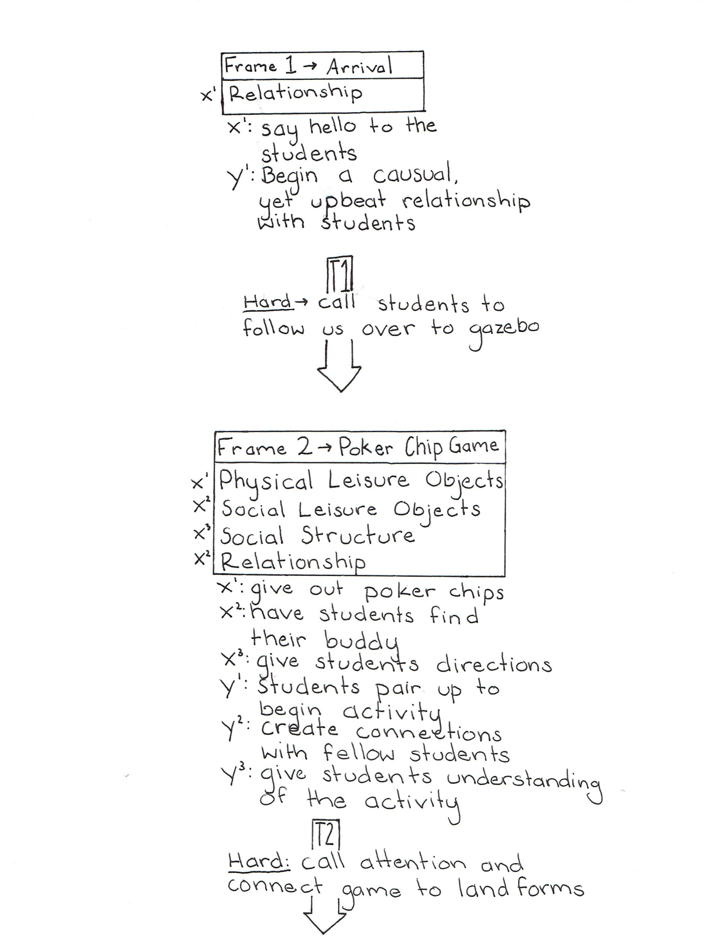

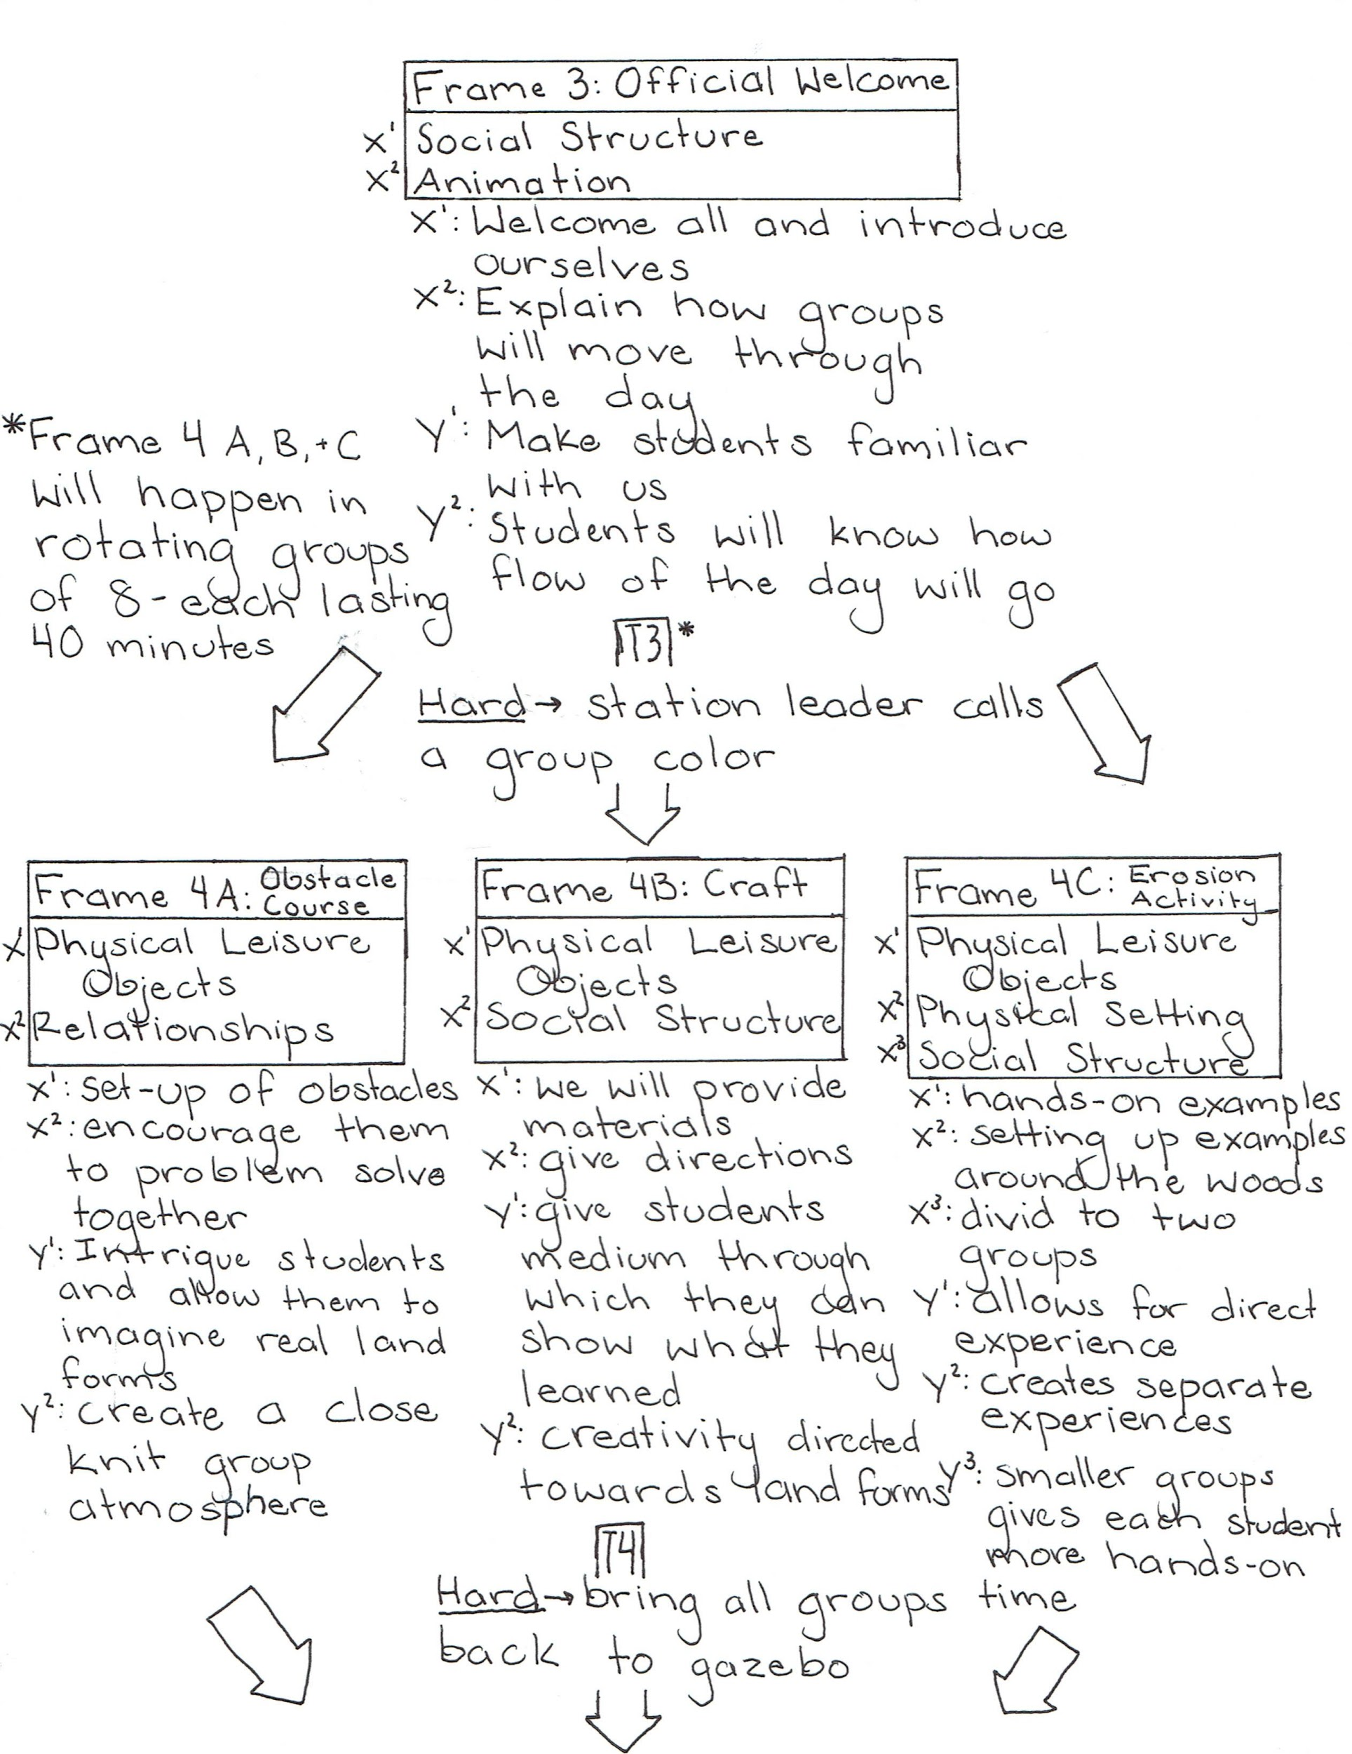

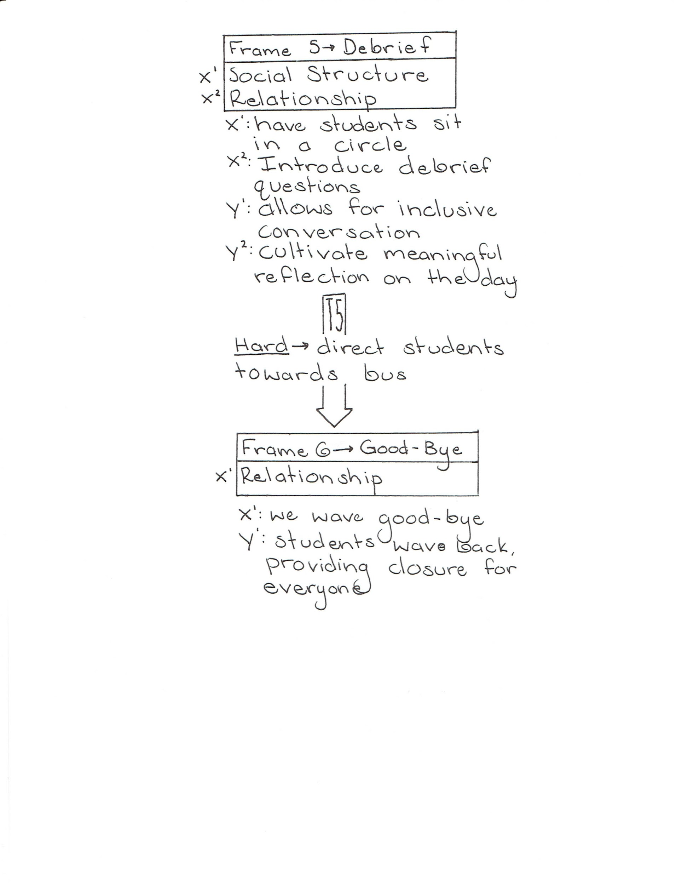

14) Program Wrap-up

To close our program we will leave at least fifteen minutes to do a debrief with the students. We will finish all of our activities and gather the three student groups together. We will then proceed to ask them meaningful questions about our program, gathering feedback from them on what we can do to improve our program for future use. When the debrief has concluded we will all walk the students back to the bus and send them back to school. Once the students are on the bus the five of us will clean up the program area and return any borrowed items to NMU. After returning items we will then go out for food and talk amongst ourselves to talk and fill out our group member evaluation forms.

Keep them in their color groups for small group debrief. Then bring them all together and each group shares something cool that happened that day.
Potential Debrief Questions:
- So did everybody have fun today?
- What did all of you enjoy most about today?
- Is there anything you all would have changed about today? Is there anything that you didn’t like?
2. Self & Peer Evaluation Rubric and Criteria.

a. Include a copy of your Group Norms/Full Value Contract and Definition/s for success.
Full Value Contract
- That each group member pulls his or her own weight.
- Everyone listens to other group member’s ideas
- Group members do their best to attend all group meetings
- All group members are present and have an active part in the execution of the program
Definition for success: For us as individuals and as a group to be “successful” the following things must occur; the program needs to transpire, and whether the program runs well or not as long as we each learn about program design and ourselves as leaders along the way.

b. Include a copy of your group’s Evaluation Rubric and Criteria for self & peer evaluations (see below, under letter “c”)

c. Include a list of individual roles, duties and/or responsibilities for each member of your group.
- Kelly Radius - Animation Plan, Design and Scan in - Registration - Print off all paperwork- manage arts and crafts
- Morgan Travis - Parent Questionnaire - Print Final Poster - Erosion Activity - Program Evaluation Plan
- Justin Ozrovitz - Budget Plan - Promotional Flyer - Map of Presque - Word Smither
- Mike Dougherty - Animation Plan - Promotional Flyer, Erosion Activity, Risk management plan
- Mike Schneck - Staff Contact, Email Drafter, Obstacle course

RE-362 - Self & Peer Evaluation
The Polar Explorers
Total Points:
Evaluator's Name: ___________________________
Evaluating: __________________________
Points | 15 | 12 | 9 | 6 | 3
Task and role assigned was completed in a timely and efficient manner | Always | Mostly | Sometimes | Rarely | Never
All thoughts and ideas were respectively considered throughout group meetings and planning. | Always | Mostly | Sometimes | Rarely | Never
Group member was involved in the group planning processes. | Always | Mostly | Sometimes | Rarely | Never
During the program the member was prepared and knowledgeable of their role. | Always | Mostly | Sometimes | Rarely | Never
Member assisted with the break down and closure of the program | Always | Mostly | Sometimes | Rarely | Never
Attendance | Always | Mostly | Sometimes | Rarely | Never
Total | /75

PART III: FOLLOW-UP ANALYSIS
1. Prepare a statement that describes
a. How your program did or did not meet your Group’s Mission statement
Mission Statement: To connect children to the outdoors in a way that fosters transferable growth through outdoor experiences.
Our group met our mission. Children were educated in an outdoor setting through group activities and other fun educational ways
b. How your program did or did not meet the Agency's Mission
Mission Statement: “A competitive Pre-K – 12 small learning community focusing on hands-on academics, integrating our global environment and the arts and technology to successfully prepare our graduates to be contributing members of society.”
Our program did meet North Star Academy's mission. Our program was highly hands-on for all of the students. Questions and activities all integrated the global environment and how we are seeing it change.
2. Prepare a statement that describes how your program did or did not meet your Agency/Group Goals
Our Agency asked us to put on a program that involved their current science lessons: land and water forms. We did meet this goal. Our program was focused around landforms and the erosion factors that can change the shape of those landforms.

3. Prepare a statement that describes how your program met or did not meet your Program Goals
a. List the Program Goals for your program
We met our program goal of operating an education landform focused day. Although we did not have the field trip at Presque Isle, we were able to implement our contingency plan by holding our activities outside of North Star Academy.

4. Prepare a statement that describes how your program met or did not meet your Program Design Goals
Our Program Design Goals:
- To effectively frontload activities to students in a concise and intentional manner before the beginning of each activity.
All activities were explained in a manner that the students would understand. All of us were actively engaging students and getting them excited about each activity provided.
- To communicate all expectations and requirements for participation to the teachers and parents of North Star Academy before the implementation of the program.
- We met this goal by talking to Kim prior to the program and seeing what her needs and requirements were. We then planned and designed our program to meet her certain needs.
- To effectively construct and organize all activities involved in the program prior to the students arriving by 12:30, on April 14, 2016
- We met this goal by meeting up prior to the program and getting everything ready. We worked well as a group and were efficient with the set-up process. We arrived at North Star about half an hour prior to the program start time to set up and get everything in place for when the students arrive.

5. Program Evaluation Plan. (This is your plan to evaluate your program not each other.) The plan should include the following elements:
a. Purpose of the evaluation (Why evaluate?)
We evaluate to be able to understand how our program ran. Also, to see what went well and what went wrong. We can take that information and use it to our advantage for future program use. It also provides the RE 362 professor with information that will help determine the group’s final grades.
b. Audience (Who is the evaluation for? What questions do they want answered? What will they do with the information?)
The evaluation is primarily for Jacquie Medina as she is the person evaluating our program. It can also be used for members of the group as well as NSA teachers.
Questions for Group:
- Did you meet the goals and objectives of your program?
Yes, all goals and objectives were met
- Was your program implemented?
Yes, our program was implemented
- What was the feedback provided regarding the effectiveness of the program implementation?
Overall, the teachers and chaperones that completed the program had positive
responses regarding the implementation of the program.
- Would you/should you implement your program again?
Yes we would. Overall the program was a success. Both the staffing and children both thoroughly enjoyed it.
c. Process (How will the evaluation be conducted?)
Our group plans to meet Friday April 22, 2016 to discuss how our program ran and do an overall debrief.
d. Issues (What questions should the evaluation address? Five P’s: Place, Program, Participants, Personnel, and Policies/administration)
- Was the setting appropriate?
Yes, overall the setting was appropriate; We were hoping to use a wooded area on Presque Isle, however, the North Star parking lot worked well.
- Was our program appropriate for the age of our participants?
The program was completely appropriate for children in grades 1-3. The tasks they
completed were challenging, but not overwhelming. Overall, the children enjoyed the
activities.
- Did we have enough supplies?
The amount of supplies we had was the perfect amount. Nothing more was needed.
- Did we feel rushed through the program? More time?
We did not feel rushed. At first we were worried due to Kim's time crunch she gave us. We however worked around it and each activity was just the right amount of time. We had to think on our toes and with the elimination of some small activities, everything worked out well.
- Did anyone feel unsure of individual duties or of group duties at any time?
No, everyone was prepared and fully aware of their role needed in the program.
- Should we have asked for volunteers to help conduct the program?
No, all group members were fully prepared to conduct the program without volunteers assistance.
e. Resources (What resources are needed to conduct the evaluation?)
The five group members need to be together and we need one person to take notes on what we are discussing.
f. Evidence (What evidence should be collected?)
- Post program parent / chaperone questionnaires
- Photos
- Final Poster on the program
g. Data gathering (How is the evidence to be collected?)
There are two things that we are going to do in order to gather evidence. The first being a questionnaire that will be given out to the parents and chaperones of the field trip. This will give us an outsider's perspective on how we performed throughout our programs implementation. The second thing we will do in order to gather evidence is to take photos of us in action while putting on the program.
h. Analysis (How can the evidence be analyzed?)
As a group we will sit down and go over the evaluations given to us. We can then reflect and talk about what went wrong and what went well throughout the program. Also, once the project is complete, we hope that Jacquie will put in her two cents.

i. Reporting (How can evaluation findings be reported?)
We plan to attach the questionnaires to the poster, allowing people to read the evaluations and come to their own conclusions on our program's success.

6. Evaluation Report. Include the following:
a. Title of the Program
Landform Fun at Presque Isle
b. Executive Summary -

i. Purpose of the evaluation
The purpose of this evaluation was to gain insight from other individuals. It was important to see how educators and parents viewed the program because ultimately, their input was most important. In order to completely understand what parts of the program were most effective, it was necessary to seek out these evaluations. We felt that using this feedback could also be useful in the future planning of programs at North Star Academy similar to this one.
ii. Evaluation Questions
- Was the setting appropriate?
- Was our program appropriate for the age of our participants?
- Did we have enough supplies?
- Did we feel rushed through the program? More time?
- Did anyone feel unsure of individual duties or of group duties at any time?
- Should we have asked for volunteers to help conduct the program?
iii. Description of the program
The program we implemented on Thursday the 21st focused on educating North Star students on landforms through educational activities and group development programs. Included in the programs were activities consisting of arts and crafts, science experiments, and an obstacle courses.
iv. Data gathering and analytical methods
We generated a questionnaire to ask the teachers and parents who would be present at the program about how we did as a group. Each questionnaire was handed out to them after the program where they would fill them out during the group debrief.
v. Findings
From the teachers and parents that filled out the questionnaire we gathered that each one of them thought the program was a grand success. There was little to no negative feedback given. They all seemed excited and willing to work with us again.
vi. Conclusions
Ultimately, we all had a blast generating and implementing our program. Although we were not able to implement the program at our intended location, we were able to adapt and still facilitate a positive learning experience for the children. The teacher and chaperones were generally pleased with the program and seemed to be impressed by how well planned the program was and how prepared the group was the day of the activities.

7. Identify the Disposition Decision you would recommend for your program.
We feel that we would like to implement the program again but we would like to have more uninterrupted face-to-face time with the teacher we are partnering with to help prevent any miscommunications.

a. If modification is recommended, identify the modifications you would recommend.
The only modification that would be recommended is that communication with the teacher we worked with was more face-to-face to prevent any confusion.

b. Justify your decision based upon your Evaluation Report
The evaluation report was for the most part positive feedback except the fact that we were unable to implement the program at Presque Isle Park. Even though this was the fact we adapted to a new environment and ran our program outside at North Star Academy.

APPENDIX
1. Include all support documents as separate word documents.
2. Reference to the Appendix documents should be correctly identified in the body of your report.

- Emails:
- Email to Tina McNeely, Elementary Principal / Montessori Program Director at North Star Academy, on February 17, 2016

Hello Tina,

We are a group of five Outdoor Recreation Leadership and Management Students from Northern Michigan University students. The class we are all enrolled in, called Program Design in Leisure Services requires that as a group, we plan and implement a program of our choice through a local agency. Collectively, our group has decided to plan a program for children focusing on outdoor education and team building.

Each member of this group has extensive experience working with children in all different settings, and because of this we believe we can make a positive impact on the students at your school. In parallel with North Star Academy’s mission, we believe that earth stewardship is an important part of being a contributing member of society. By creating an effective and efficient outdoor program, we believe that students will leave having a deeper understanding and connection to the local environment.

We hope to meet with you in the near future in order to further discuss our potential program ideas in conjunction with the needs of North Star Academy students.

Sincerely,
Mike Schneck, Kelly Radius, Mike Dougherty, Morgan Travis, Justin Ozrovitz

B. Email to Kim Pettit regarding classroom visit and program confirmation

Hello Ms. Pettit,

My name is Michael Schneck and I am part of the Outdoor Recreation Leadership and Management Program at NMU. I am currently in the Program Design in Leisure Services course, which requires student groups to design, create and implement a program with an agency in the Marquette community.

Last week, another group member and I met with Tina McNeely to discuss leading a potential outdoor activity with the 1st-3rd grade Montessori classroom. This program would involve an afternoon at Presque Isle where students would be led in an educational outdoor activity.

Our group is hoping to meet with you in the coming week or two to further discuss this opportunity and hopefully put together a plan of action for the coming month. Please let us know what dates and times work best for you and hopefully we can figure something out. We hope to hear from you soon! Have a great week!

Sincerely,
Michael Schneck

C. Email to Peter about O’Rumpus Room Sit Pad Rental
Hey Peter,

On April 21st we are implementing a program for North Star at Presque Isle and are in need of 10 sit pads for students to sit on.

Curious if this is possible? I know you said we may need to make a couple more.

D. Email to Kim asking her to send out our promotional poster to parents

Hey Kim,

Attached is a flyer that we put together promoting the upcoming field trip to Presque Isle on April 14th. For some reason the formatting is coming up weird on my MacBook and I’m worried it may not come through correctly to you. I'll give it a go anyways and attach the file.

If you can, please send this out to all parents; whether it be via email, or with the children when they go home. We just want to give the parents a heads up and what to expect for that day.

Please let me know if the file opened correctly in Microsoft Word. You'll know if it worked or not; I hope.

E. Email to Kim catching up on things
Hey Kim,

So we're just under ten days until the implementation of our program on Presque Isle. Below are a few things we need from you if at all possible.

1. Can you please send the attached improvised flyer with updated information, and the new date to all parents?

2. Can you please let us know how many parents will be there along with your teaching assistant? Once again, sorry to hear about your ACL; you'll be back on your feet before you know it!

3. One of us will be stopping by sometime next week to drop off cut up shirts to distinguish groups while on Presque Isle. We only ask that YOU split up the groups. 3 groups total.

4. Can you possibly front-load the landform day to your students? Get the "pumped up", if not, I know you're busy, no worries.

5. Are there any students that can't have their picture taken? We want to take a few pictures of us in action to use for our final report that we have to to turn in.

6. What is the EARLIEST time the students can arrive at Presque Isle? And when is the LATEST they can leave?

F. Email to Tina discussing risk forms

Hello Tina,

My group is currently filling out our program report for our Program Design in Leisure Services. We were wondering if you would be able to send us any risk management forms, waivers or releases? We need to somehow prove that we are aware of all paperwork regarding risk and have to provide them in our program report if possible.

Thank you in advance for your help!

Sincerely,
Mike Schneck

G. Email to Kristi Evans about potential Press Release

Hello Kristi,

My name is Michael Schneck and I am an Outdoor Recreation Leadership and Management major here at NMU. For my Program Design in Leisure Services class, we are required to design, plan and implement a program with another agency in the community. My group will be taking putting on a program at Presque Isle for North Star Academy Montessori 1st-3rd graders. Our main focus for this program will be the topic of landforms as well as group and community building among the students.

As a group, we hoped to reach out to you in regard to creating a press release for this event. We are hoping to potentially get some coverage so that community members can be more aware of experiential education opportunities, while also letting the public know how their parks are being utilized. Please let us know if this is something that is at all possible. Below I have listed the information for this program.

Where: Presque Isle Park
When: April 14th, 2016 (12p-3p)
What: North Star Academy Montessori students will be taking part in a day of activities at Presque Isle with a group of students from NMU's Outdoor Recreation Leadership and Management program. Students will be taking part in experiential activities based around basic geology and landforms while also learning how to better work together.

Sincerely,
Michael Schneck
II. Questions to ask Kim Pettit, 1st- 3rd grade Montessori teacher at North Star Academy, during meeting with her on Friday March 11, 2016

- What type of material are your students covering now? (Geology)
- What date/time would you like to do this program?
- Are they any specific limitations for certain students or groups of students in your classroom (i.e. learning disabilities, physical disabilities, behavioral issues)
- When could we come talk to the class?
- How do you contact parents most often/efficiently
- Favorite type of spaghetti sauce
- What was your first pet?
- How do you feel about a scavenger hunt at Presque Isle?
- Any rules in regard to food?
- How many students exactly do you have?

III. Risk Release Form

IMPORTANT: THIS IS A LEGAL DOCUMENT

Please read and understand this document before signing. If you have any questions please ask your instructor or consult an attorney.
Northern Michigan University has done everything possible to assure that our participants' experience will be rewarding. We wish to inform our participants that Landform Fun at Presque Isle is not risk free. The same elements that contribute to the unique character and fun of the course can cause loss or damage to equipment, injury, illness, or in extreme cases, permanent trauma or death. We do not want to heighten or reduce your enthusiasm for the experience, but we do want you to know in advance what to expect, and to be informed of some of the possible risks. We ask that you read this, sign it, initial where indicated, and return it to your instructors.

ACKNOWLEDGMENT OF RISK

This program requires participation in group initiatives, games, and arts and crafts. Participants will be moving through three different stations as the program goes on. One activity will be an obstacle course that involves: balancing, stepping over objects, running from place to place, and jumping up and down. Another activity will be arts and crafts. This will involve gluing tissue paper to a plastic lid. The last activity will be an interactive study of different agents of erosion. This will involve working with water, sand, sugar cubes in trays. These activities are, by their nature, physically and mentally demanding, subjecting the participant to certain stresses and hazards, not all of which can be foreseen.

Accidents can occur during participation in the activity and while travelling to and from the activity area. Participants will be holding each other in “wheelbarrow” form. Also, participants will be performing in activities that involve small obstacles. Movement between different activities could result in tripping or stumbling on to the ground. This list is not an exclusive or exhaustive list of possible injuries, trauma or accidents that may occur while participating in Landform Fun at Presque Isle. Most of these injuries are rare and you are not likely to encounter them, however, they have occurred and you need to know about them and other possible injuries not mentioned above. These injuries occur more often when participants are using drugs (including caffeine and tobacco) or alcohol, or are not physically able to undertake the activity.
I certify that I am fully capable of participating in Landform Fun at Presque Isle. I state that I have read the above statement on some of the possible risks in this course. Therefore, I assume full responsibility for myself for bodily injury, death and loss of personal property and any expenses as a result of my negligence, negligence of other participants on the course, or the negligence of Northern Michigan University. I also understand that Northern Michigan University reserves the right to refuse participation by any person it judges to be incapable of meeting the rigors and requirements of the course. I certify that I am in sufficiently good health to undertake the course and that Northern Michigan University has made no representations to me with respect to my fitness to undertake this course. I further agree to notify the instructors of any hazardous, unsafe, pertinent medical and/or health information, or injury-producing conditions, which may affect the safety of this course.
CONTRACT, WAIVER, RELEASE AND INDEMNIFICATION

I agree to indemnify and hold harmless Northern Michigan University, RE 362 students, their agents and employees from all claims, damages, losses, injuries and expenses arising out of or resulting from participation in Landform Fun at Presque Isle. I further agree to release, acquit and covenant not to sue Northern Michigan University, RE 362 students, their agents and employees for all actions, causes of action claims or damages, damages in law or remedies in equity of whatever kind, including the negligence of Northern Michigan University, RE 362 students, myself, or other participants on this course against Northern Michigan University, arising out of participation in this course. In short, I cannot sue Northern Michigan University, RE 362 students, their agents or employees, and if I do I cannot collect any money.
I agree to the site of any lawsuit and the law governing any such lawsuit shall be Michigan and governed by Michigan law. The terms of this agreement shall continue and be in effect after Landform Fun at Presque Isle has ended.
Any liquidated damages, I hereby agree that if Northern Michigan University or RE 362 students are forced to defend any action, lawsuit or litigation by myself, my executors, or my heirs, on my family's or my behalf, my heirs or executors, I agree to pay Northern Michigan University's or RE 362 student’s costs and attorney fees if they successfully defend such action, lawsuit or litigation.

IMAGE RELEASE: By my initials, I _________ authorize and release to Northern Michigan University the use of my image in any photograph or video recording for any purpose of Northern Michigan University.

EMERGENCY MEDICAL TRANSPORTATION/TREATMENT: By my initials, I_______ hereby give permission for transportation to any medical facility or hospital and I authorize any qualified course instructor, leader, participant, or medical personnel to render necessary emergency medical care for myself.
[_____] By checking this box, I indicate that I have adequate insurance for myself.

I, ___________________________________________________________, of my own free will, for my family,
(PRINT NAME)
my minor children, my heirs and executors and myself, have read, understand and acknowledge the risks and liability for myself this _________day of _______________20____.
SIGNATURE: ______________________________________________________________________
A copy of this release can be used as if it were an original.
Include the following paragraph if you are working with minors:
I, (parent/guardian name) ___________________________________________________________, of my own free
(PRINT NAME)
will, for my family, my minor children, my heirs and executors and myself, have read, understand and acknowledge the risks and liability for my participant this _________day of _______________20____.
SIGNATURE:______________________________________________________________________
A copy of this release can be used as if it were an original.

IV. Map of Program
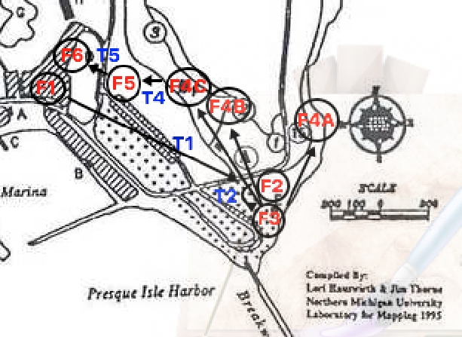

V. Promotional Flyer sent to the parents:
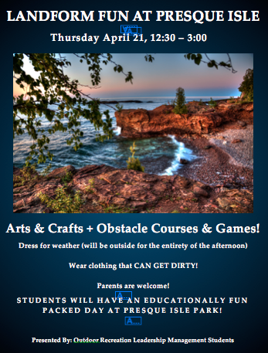

VI. Parent Questionnaire

1) For the purpose of our program, do you feel that our setting was appropriate?

2) Do you feel that the program was designed appropriately in regard to the age of the
Participants?

3) Do you feel that we were well prepared and had enough supplies for all of the participants?

4) Do you feel that program leaders had efficient time management?

5) Do you feel the program leaders were competent in their roles?

6) Do you feel that we had enough people working the activities

7) Were students overall engaged in activities throughout their experience?

8) What could be done to make these lessons more effective for a diverse set of learning styles.

VII. NMU Public Safety Incident Report
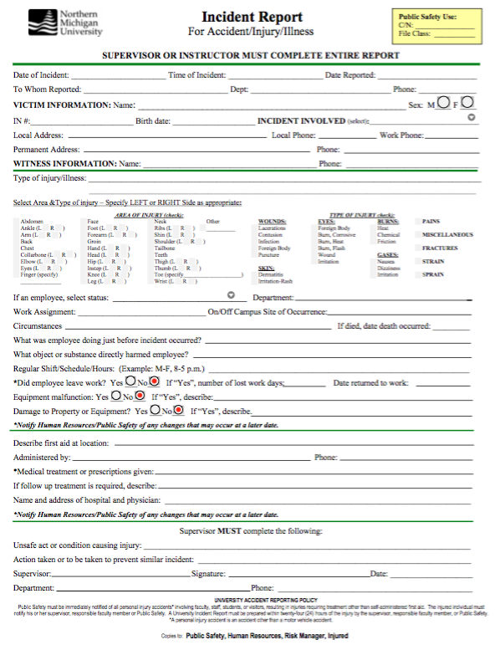

VIII. Lesson Plan

Have Kim split class up into 3 separate groups. We will deliver group distinctions prior to April 21st to Kim to pass out to students.

Bus drops them off in Moosewood parking lot. We walk them over to the gazebo. Poker Chip Game / Construction Paper; Introduce ourselves.

3 Stations - Split class into 3 groups. 9 Student/group

Station 1 - Team Building Game/Initiative - Beach Ball
Framing:
- Assemble students in a circle and explain there will be two activities and the expectations for both (respect, no roughhousing, positivity etc.)
Beach-ball Activity:
  - Pull out beach ball and explain the premise of the beach ball game
  - Provide a quick example with group member; ask if anyone has questions/if anyone feels confused.
  - Begin activity
Obstacle Course Activity:
- Assemble group in semicircle in front of obstacle course
- Introduce the activity as if the students are Polar Bears, moving from ice to island to a mountain valley because of their shrinking habitat.
  - This is a great time to talk about melting glaciers and how Polar Bears are moving farther south. This is relatable to their school mascot and also involves characterization of the students which will make them more likely to be interactive and having fun.
- Clearly explain the activity and make sure you clearly state that students can’t move forward until they have answered a question regarding the landform they are on.
Activities:
- Beach-ball Activity
  - Group members will have a Beach Ball that has landforms drawn all over it.
  - Students will stand in a circle and throw the beach ball to one another popcorn style.
  - Whenever a student catches the beach ball, they will look at the landform that is closest to their right hand.
  - After students look at the landform, they will have to do their best to try and name what it is. If they do not know what it is, the group can help them.

- Obstacle Course
  - Step One (Glaciers)
    - Students will move one by one onto a large “glacier” (white sheets). There will be three other pieces of paper that get smaller one by one. Students must balance and jump from landform to landform, answering glacier related questions at each piece.
  - Step Two (Island)
    - Students will answer one last question to jump from the smallest glacier to the island. They will then wait at the island until all students have arrived.
    - When all students have arrived, we will discuss Polar Bears eating habits and tell students about melting glaciers and human impact in regard to this (in very simplified terms). This will be the reasoning behind moving to an island from the glaciers.
    - There will be a variety of stuffed animals placed around the island. These animals will represent the seals that Polar Bears are known for eating
    - After explaining this, students will be required to work together in order to retrieve the stuffed animals from outside of the island. Only their arms will be able to touch the ground outside the circle (representing the struggle to get food in open water.)
    - This will have a double purpose as a team building activity as well as a representation of how environments affect landforms and the animals that use them.
    - Once all stuffed animals are retrieved, students will answer one more question each in order to move onward to the next obstacle.
  - Step Three (Mountain Valley)
    - There will be sheets hung on either side to represent mountains and in-between (the valley).
    - They will move through obstacles, which will represent rocks, fallen trees, drainages and other things that are found in valleys. Once they get to the end, they will answer one last question in order to finish the activity.
    - At the end of this, students will do their “team cheer”, followed by a quick and simple debrief.
  - Step Four (Debrief)
    - The group members will ask a few key questions
      - What is something you learned?
      - What was the easiest part?
      - What was the hardest part?
      - What is something you are curios about?

Landform List:
- Valley
- Volcano
- Coral Reef
- Mountain
- Peninsula
- Island
- River
- Bay / Cove
- Arch
- Plateau

Station 2 - Arts and Crafts - Creating tissue paper “sun catchers” that show different landforms.
- Give each student a small clear plate
- Ask them before they start if they can name a few types of landforms
- Show example and show them techniques to make the sun catcher
- Hand out supplies
- Let kids get to work!
- After kids get a chance to make two or three sun catchers group them again and have each kid show at least one of their sun catchers

Station 3 - Erosion Activity- Instructions: Your group will be assigned one ‘agent of erosion’ from the following list: running water, waves, glaciers and wind.

Each group is a top-secret government department and your task is to compile a dossier on your ‘secret agent’. This file should contain the following information: Statistics on agent - size of particles, speed of process, where found in the world, etc. Modus operandi of the agent - how the secret agent actually causes erosion. Thwart potential - an imaginative way that an agent may be stopped (or can they be stopped?). Discuss ways in which this type of erosion agent interferes with human’s plans and ways to prevent its interference. Scene of the crime - drawings and pictures of the scene of the erosion agent, where it operates and areas it causes problems.

*We will each be dressed as a landform
- Volcano
- Ocean
- Peninsula
- Mountain
- Butte

