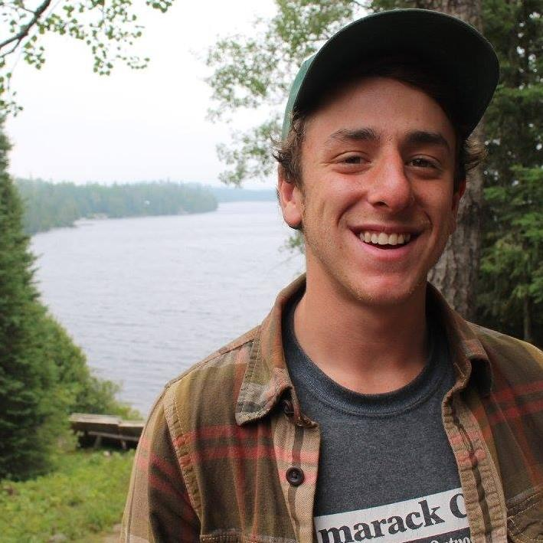
Biography:

Hey everyone! My name is Justin William Ozrovitz. I was born on August 30, 1993 at Beaumont Hospital in Berkley, Michigan, and spent my childhood growing up in a small urban home just outside of Detroit in Oak Park. I spent my childhood surrounded by loving individuals, including my mother Sharon; father Bruce, and two older sisters, Lauren and Alyssa. I spent my young academic years at two different grade schools, and one middle school before attending Berkley High School in Berkley, MI. There, I spent most of my time at either playing the trumpet in the marching band, or hitting the links with my fellow buddy golfers on the golf team. After high school, I decided to attend Oakland Community College; there I obtained an associates degree in liberal arts. I then took that degree and transferred to Northern Michigan University where I began my studies in their Outdoor Recreation Leadership Management program. I have always had a passion for the natural world and felt that going to NMU would not only be best for my studies, but for me to grow as an individual as well. While attending NMU, I found myself taking advantage of what Marquette, Michigan had to offer and would spend my free time hiking, canoeing, rock climbing, and playing ultimate Frisbee. I am currently en route to completing my degree, and am looking to peruse something that keeps me outside and teaching others, two things I enjoy the most.

Art Piece Statement:

For my final project, I decided to create two Shabbat candleholders. I did so for two reasons; the first being that we needed some new ones for our Shabbat dinners, and the other being that I have always wanted to make a pair, as both of my sisters did when they were younger. Growing up, my two older sisters had the chance to make some in their Hebrew school classes, but due to poor quality, they just didn’t last; new ones were needed. One thing I wanted to explore and get out of this project was working with my hands and also side by side with my father. Growing up, I was able to watch him use tools and work with wood, two things I’m not very good with, so working along with him was a big plus; I also don’t see him much anymore so there was that. A goal and parameter that I gave myself for this project was to use metal and wood! I am rarely able to work with those resources to create things, and this project gave me the perfect opportunity to do so.

