Justin Ozrovitz
Monday, February 15, 2016
RE 362 Program Design in Leisure Services
Leisure Program Critique - Volunteer

Part 1: Involvement (Volunteer in a Leisure Program)
- Name and Mission of the Agency providing the program - UP 200 Sled Dog Races and Midnight Run - To promote the sled dog sport, educate the public about sled dog activities, and sponsor a continuous, mid-distance sled dog race in the Upper Peninsula of Michigan.
- Name of the Program & Type of Leisure Activity – UP200/Midnight Run Sled Dog Championships
- Brief description or summary of leisure program – Sled dog race finish in downtown Marquette
- Web link - http://up200.org
- Date and time of your involvement, total time of your involvement and selfie if appropriate – February 14th 8am-12:00pm - Total Time = 4 Hours
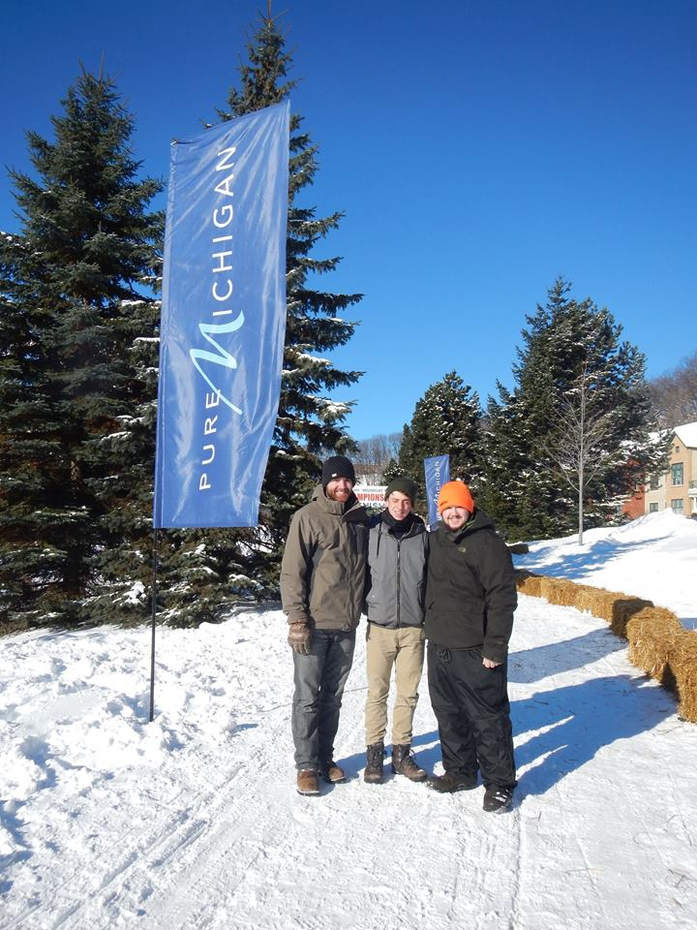

- Brief reflection of your experience volunteering for this program and agency
Overall, my volunteer experience for the UP200 Midnight Run was a positive one. It was new, fun, and fast paced, all things I thoroughly enjoy. It all started about a month prior to the race with a call to Anna, the volunteer coordinator. She kept me in the loop about where they’re going to need me and what time as well. Fast-forward to the finish day and all of this changed. I received an email from Ross, the start and finish line coordinator saying that he’ll need me at the finish line at noon the next morning. Fast forward to the morning of the finish and I got a call from Anna “freaking out” saying she needs me at the finish line as soon as possible! This call came in at 7:30; I got there at 8:00. Apparently Ross emailed me at 4:30am saying hell need us there at 8:00, I was clearly asleep at that time and there was no way for me to know that. If there’s one thing that I would change about this whole experience is better communication with the volunteers, and keeping them in the loop a little better.
Overall the race was enjoyable and passing out hot chocolate was actually more fun than it sounds. Interacting with people and making them smile with a warm liquid warmed me up inside as well

Part 2: Interview
- Name of the Agency & brief description of agency (include mission)
- Upper Peninsula Sled Dog Association
- To promote the sled dog sport, educate the public about sled dog activities, and sponsor a continuous, mid-distance sled dog race in the Upper Peninsula of Michigan.
- Name – Ross Anthony
Title – Board Member
Role of the person interviewed - Start & Finish Coordinator
- List of questions asked and summary of responses –
Q: Does the number of volunteers vary each year? Are there some years that lack volunteers? If so do you have a contingency plan to get more hands on deck?
A: Yes the number of volunteers varies each year; they do however get an average of 500-600 people who want to help out which is mind blowing to me. The only issue that the board runs into is finding people to man the more remote checkpoints in the backcountry; most people are only willing to help out at either the start or finish of the race, due to the closeness to their homes. Anna, the volunteer coordinator does have a list of past volunteers to reach out to if she’s in desperate need. This rarely is ever need though. Also, if need be the board can reach out to newspaper and radio stations and ask them to do some publicity for the race, asking the public to volunteer.

Q: After the race is over, what is your job? Does the planning process for the next year’s sled dog races start right away?
A: Ross is a board member and leads all meetings following the sled dog race, the day after the race the board members meet up for a meeting with some of the Mushers to talk about what they can change for the following year; what worked, and what didn’t work. The planning for the following years race starts right away!

Q: Do you and the UP200 crew have meetings on a regular basis on how you are going to run the program?
A: The board members try and meet once a month to talk about next years race. Leading up to the race they have them more frequently. They actually had a meeting the night I interviewed Ross; he offered me to come to it but I had work that evening.
Q: Do you make notes on what you can improve on for the following year? Maybe things that could or should be changed.
A: Notes are taken and kept for future years. Before Ross was the start/finish coordinator a lady, I forgot her name gave him a stack of papers with previous years notes; he’s used these notes for the past few years to help him with the implementation of the races.
They also make notes on what went wrong, or what the need to change for next year. For example; a Musher got stuck on the trail and her SPOT device didn’t work, the board didn’t have an evacuation plan, or any plan on how to deal with this issue. Also, this year they lacked barricades at the finish line, this is something they need to improve on for the following year.

- Brief reflection on your experience and information that you gained

Ross was very laid back and was eager to talk to me about what he does. I asked him if he races dogs, and the reasoning for him doing what he does. His response was that it’s all about the community; he loves seeing the community come together and grow. This was the first interview I’ve ever done and overall it was an enjoyable and positive experience. I look forward to doing more.

Fun Fact: The UP200 brings in over 2 million dollars to the city in the one weekend it’s going on!

Answer the following questions for Part 3:

1. INTERACTING PEOPLE
- Who are the people? Provide their general characteristics
The people at this event ranged from all age groups, babies, to senior citizens. There were both male and female spectators for all over the world. I heard quite a few different languages spoken while passing out hot chocolate.
- How were they recruited to participate?
The UP200 does a lot of publicity and promoting to get people to come to the event. They use the news, the mining journal, flyers, and brochures.

- What would happen to the interaction if different people were targeted/recruited?
I don’t think that the event would change much if different people were targeted. I see the UP200 as targeting everyone and anyone, there’s not one set of people they’re trying to get to come. They want the most people possible showing up to the race. Overall the event was designed for all types of people, young and old, male and female.

2. PHYSICAL SETTING
- Where was the program located?
The program was located outside in Mattson Park, in the lower harbor of Marquette, Michigan.
- What made the setting unique?
The location runs right a long the lake and has a beautiful view of the Ore Dock. This gave people who are not from Marquette a beautiful taste of what it has to offer.
- What were the limitations of the physical setting, if any?
I honestly didn’t see any limitations of the physical setting. The area was pretty open and the views were beautiful. The parking lot was large to hold spectators cars as well.
- Were there any necessary alterations done to the setting? If so, what kind?
The physical setting was altered. There were barricades put in place so that the dogs are separated from the onlookers. Other than that not much was changed to the land. There were however a few “huts” put in place for people to pass out hot chocolate and to also warm up. This was the coldest day of the year
3. LEISURE OBJECTS
- What were “essential” leisure objects?
Dogs – Physical and Symbolic
Barricades - Physical
Microphone and amplifier – Physical / Social
Hot Chocolate – Symbolic for the cold weather
Sponsorship Signs – Physical and Symbolic
- Identify the type of objects in the program as 1. Physical, 2. Social, and/or 3. Symbolic
(Done Above)

4. STRUCTURE
- Identify and explain the kind of rules the program had as being
1. Laws
There were certain rules that the Mushers had to follow, they had a list of things that they had to have on them at the finish line, I saw Ross checking the Mushers in.
As for the participants, the only rules were to not cross the barricade.
2. Registration/refund policies
As a volunteer I had to contact Anna Savord and let her know I was interested and helping out. She kept in touch with me and kept me up to date on where I needed to be and what time.
3. Relational rules of everyday discourse
Be considerate of others and be a good human being in public.
4. Codified rules of a game
All rules for the UP200 are listed in this PDF file.
http://up200.org/wp-content/uploads/2016/02/2016-UP200-MR-Rules-FINAL-01-27-2016.pdf
5. Ceremonial rules of a game
I was not at the entire finish for the race an am unsure whether or not they had a ceremony for the winners. They did however announce what place each Musher was once they came through the finish line.
6. Self-directed/Non-Competitive
This event was self-directed and was competitive. Each Musher was for themselves and was against each other. The UP200 is a fun race but also pretty intense due to the potential large cash prize.
- What was the format of the program? Identify and explain using:
Special event
Competitive League and/or Tournament
Open House/Drop-In
I viewed the UP 200 as a special event, due to the fact it only occurs once a year. It is a competitive race with large cash prices involved which males is a competitive league. And the event is open to the public and anyone who wants to come which makes it an “open house” drop in type event.

5. RELATIONSHIPS
- Were pre-existing relationships necessary for program success? If so, what were those relationships? If not, did the programmer try to create a relationship or not?
As it goes for the participants of the even, the Mushers, I would assume that most of them know each other because they share the same love for dogs and interests, I however don’t think that has any bearing for the program to succeed. In my eyes this is a race and its every man / woman for themselves.
As it goes for the spectators, no previous relationships were needed in order for the program to succeed. I would assume that most of the people there didn’t know each other; they just wanted something to do that day with their family, therefore that’s why they were there.
Some people were newcomers, like myself, and I would assume that there are a handful of returners that come to the sled dog race year after year.
As for the programmer trying to create relationships, I’m not exactly sure if that was one of their goals. They were however very enthusiastic on the microphone which got people amped up and excited about the race,; This could have an influence on people coming back next year; the fact that is was “hype” and enjoyable.

6. ANIMATION
- How was the program set into motion?
Setup Crew (me), came early around 8am to help setup the finish-line
Participants slowly staggered in and started taking their spot around the barricades
A few hours later the first Musher came through past the finish line
People then mingled and stayed around waiting for other Mushers to come through
After the last Musher came, people left.
- How was it sustained?
People were pretty stationary for most of the event. People did move around but for the most part people were just lined up along the barricades.
- Were there leaders?
The board members were the leaders of this program. They took control and were all hands on deck getting things done. They did use volunteers to help them out though. I viewed Ross as the biggest leader there. He was moving 1000 miles an hour, running from place to place; He was also on the microphone.
- Was information about the participants’ movement distributed, if so how was this done?
As a volunteer I was given instructions on what do to and what needed to be done. I didn’t however have an agenda or itinerary that I had to follow. To be completely honest it was pretty unorganized
- Did the animation involve any type of automation? If so, what was it?
The animation didn’t involve any automation. The finish line was stationary. And people basically stayed in the same spot throughout the finish of the race.

