CP - INTERPRETIVE PROGRAM COVERSHEET

Title of CP: William Austin Burt, a Navigator Extraordinaire; Iron Has Been Found!
Interpreter’s Name: Justin Ozrovitz
Date of Program: Wednesday, December 1st, 2015
Location: Wooded lot behind the PIEF. The main trail leading through the red pines. From the sidewalk with the orange cones covering the potholes, to the parking lot on the other side. I will be stationed in the middle of this trail. This is the same trail we took when we went on the Guided Walk & Tour of the wolves. (I will be stationed where the red “X” is)
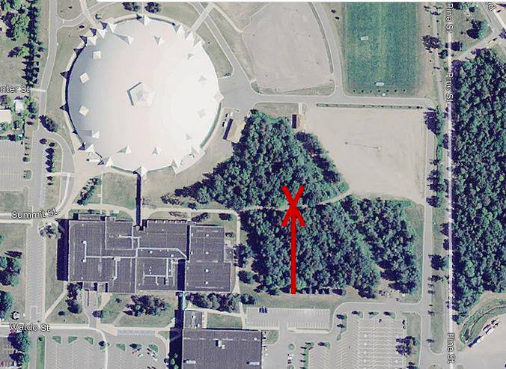
Resource: William Austin Burt
Theme: William Austin Burt played a vital role in the discovery of Iron Ore in Marquette and it’s surrounding area.
Name of Character: William Austin Burt
Summary of Characterization Program: My audience will get an overall understanding on William Austin Burt as a person and as an explorer her in the Marquette Area. They will get an overview of his early life, mid life, and life as an Upper Peninsula surveyor.
Your GOALS for this interpretive program (what you want to accomplish through your program):
Goals for myself:
- Do not use filler words.
- Refrain from looking at my resource. This time I am the resource, so this shouldn’t be that hard.
- Look at my audience, and everyone in it. Not just the people I feel comfortable talking to.
- Create a timeline for my talk and follow it, basically an outline to follow
- Study my character AS much as possible so I don’t have to use notecards.
- I also want my audience to learn a lot abut William Austin Burt, and how his studies have had a giant impact on Iron Ore industry within Marquette.

Justin Ozrovitz
December 1st, 2015
Characterization / Personification Planning Worksheet (CPW)
1. Logistics

- Specific location of the GWT. Wooded lot behind the PIEF. The main trail leading through the red pines. From the sidewalk with the orange cones covering the potholes, to the parking lot on the other side. I will be stationed in the middle of this trail. This is the same trail we took when we went on the Guided Walk & Tour of the wolves. (I will be stationed where the red “X” is)

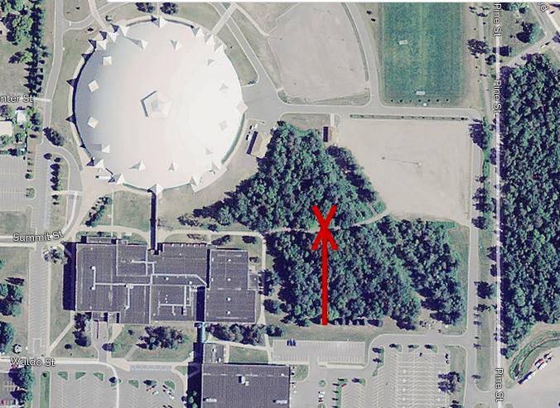

2. Agency & Audience

a. Name of the Agency - Bureau of Land Management in Marquette Michigan
b. Mission of the Agency – “To manage and conserve the public lands for the use and enjoyment of present and future generations under our mandate of multiple-use and sustained yield”
c. Audience - My audience will be student attending Northern Michigan University, ranging from the ages 18-25. The students will be a part of the Outdoor Recreation Leadership Management program.

3. Interpretive Performance – Characterization (Historical/Cultural)

4. Organization
- Topic - William Austin Burt
- Sub-Topic - William Burt surveying land in the Upper Peninsula
- Substantive Focus - Historical/Cultural
- Theme – William Austin Burt played a vital role in the discovery of Iron Ore in Marquette and it’s surrounding area.
- To educate my audience on how I was able to use one of my most famous inventions to survey the lands of Marquette, and how me doing so brought a giant craze for iron ore to the surrounding areas.
- Theme Development Outline
  - Topic #1- who am I?
    - Introduction – Hello everybody, my name is William Austin Burt.
    - Body- let me tell you a little bit about myself; I was born on my father’s farm on June 17th, 1792 in Petersham Massachusetts. I have many other brothers and sisters that I love spending time with. As time went on though some of us split up, and wanted to peruse different things in our lives. Me, I loved going to school and learning. Some of my school interests include science, mathematics, astronomy, and navigation. I had always hoped that these skills that I practiced for so long would help me be the grand master (captain) of a boat one day. That however didn’t happen. Ever since my father got lost at sea my mom has been heartbroken; I must respect her and not be a boatman. I remember my dad sending me to school and me feeling like it was too easy for me. My dad then pulled me out and decided to homeschool me for a few years. He wanted me to learn at the pace I was good at; which was fast. Later, when I was 16 my father sent me back to school to learn the subject I took passion on at a higher level. I did that for a few weeks and continued educating myself on my own.
    - Transition - Due to my mother not letting me become a captain of a boat I decided to try something I never thought I would do, which was enlist in the United States army. This however stopped me from all of my studies and practices I had going on.

  - Topic #2
    - Intro - The army wasn’t for me so I decided to drop that and continue what I love, which was navigating and survey lands.
    - Body- In 1813 I moved to New York to do some navigation studies. There I met my current wife, Phoebe Cole; I was only 21 years of age at that time. We ended up having five children. After being in New York for some time I decided to take my work on foot and do some traveling. I hit Pittsburgh, Cincinnati, St. Louis, back to New York, and then ended up down in Detroit Michigan. Here in Detroit I started the construction of one of my inventions, which I call the “Solar Compass”, we will talk about that in a little bit. While in Detroit, I took a break from my navigating and took on the skill of being a Millwright, I love working with gears and thought this might be the trait meant for me. I worked as millwright down in Detroit for about 25 years. While also being a millwright I held jobs in Macomb County as a postmaster and a court judge. At that time I was approached by the United States Government and was asked to become a United States Deputy Surveyor up in the Upper Peninsula. Apparently they were in need of my expertise.
    - Transition - After the death of Dr. Douglas Houghton, I was asked to take over his position and continue the work he had started in the Marquette area surveying the land. I was given all of his previous notes as well as a few of his men that were on his exploration with him.

  - Topic #3
    - Intro - On September 15th 1844 my crew and I started off where Dr. Houghton left off. We started our surveying of the land on a rocky cliff, just south of teal lake. All of a sudden the exploration took a halt, our compasses weren’t working correctly!
    - Body – My crews consists of me and seven other men. Me, I’m the navigator and commander in chief on this exploration. My compass man is one of my best friends, William Ives. Also in this crew are my three chainmen and axmen, Harvey, Richard, & James. Jacob Houghton, Dr. Houghton son worked the barometer, and John Taylor, along with my good pal Booney were the packmen. They carried all of our gear. While looking down at my compass during the survey along Teal Lake I noticed that the needle would not stay in one stop! It was all over the place. I then said to my men “ Boys, look around, see what you can find”. My crew split up; some went south, some went east, some went west. All of them however came back with handfuls of the mineral iron ore. Apparently the iron ore disturbs the magnetic field in the compass; therefore we weren’t able to get accurate readings. Me, I’m all about doing the work right and this just, wasn’t right. I reached into one of my packs and pulled out my invention “The Solar Compass” and said to myself. How can this land be surveyed without this invention, I then replied to myself with it cant! My device is very neat and does not need the use the magnetic fields to give me my direction. I however use the sun with my invention. I hold it in a particular way and make sure the sun hits faceplate of the compass, this then gives me a very accurate reading on which way to go. After we finished up some surveying work with my solar compass we thought wow, this iron ore must have some use, there is so much in this area that it should be mined.
    - Conclusion – I’m curious what this areas going to use all of this iron ore for. Anyways, I’ve got to continue my surveying work. Goodbye for now!
- Perspective to be used – I want to tell my audience about the development through time of William Austin Burt surveying land in the Upper Peninsula.
- Title - William Austin Burt, a Navigator Extraordinaire; Iron Has Been Found!
- Details of character’s life and setting
  - Name- William Austin Burt
  - What is my occupation? I am a land surveyor working for the United States Government; I am currently located in Marquette doing some work.
  - Where do you live? I am currently on the move around Marquette, daily. I survey different parts of the town and usually spend my nights outside with my fellow workers.
  - What is your social status? – I am a workingman that has held a lot of positions with government agencies.
  - When were you born? June 17th, 1792 - How old are you? I am 52 years old
  - Where was your place of birth? I was born on my father’s farm in Petersham, Massachusetts.
  - What is your economic status? Right now I’m doing fairly well. The government job keeps me going and on my feet.
  - Hobbies and Interest - Some of my hobbies include navigation and boating. I also enjoy mathematics, astronomy, and natural philosophy. At the age of 18 I purchased a broken surveying compass repaired it, I then used it to survey the area surrounding my parent’s home. Some of my other skills include inventing things, surveying lands, and working with gears.
  - What level is your education, where was it, who taught it? I ended up attending my local district school for about three week, and then left. I found myself really good with arithmetic studies. I felt like school wasn’t enough for me so I decided to study it on my own. When I was sixteen, my father sent me to school for science, and math, my two favorite subjects to study.
  - What will you be wearing? I am wearing a button down long sleeve shirt with green pants. The shirt will be rugged and dirty due to me being in the woods for my occupation. I will also have on my backpack and a walking stick.
  - What do you carry around with you? Daily, I carry around with me my solar compass, along with my backpack filled with water food, paper and a notebook for me to jot down my notes while surveying. I also carry some postcards with me to write my wife phoebe when I’m in the field
  - What do you do to make a living? I am a United States government deputy surveyor. I survey lands and create boundaries. I also enjoy inventing things with my free time, which isn’t much.
  - What are the names and ages of your brothers and sisters? N/A
  - I am married to Phoebe Cole. The date was July 4, 1813; I was only twenty-one years old.
  - When/where were you married? In new York, July 4, 1813
  - Why didn’t you marry? N/A
  - What are your children’s names and ages? My wife and I have five boys; John, Alvin, Austin, Wells and William.
  - How did you arrive to where you are living now? After the death of Dr. Douglass Houghton in 1845, I was asked to take over his geological notes and complete the work he hadn’t finished here in Marquette, Michigan.
  - How is your physical health? I am feeling very good, I feel strong from all of the walking I do.
  - What was/is important to your character? My children are very important to me, as they are not only my kids but my coworkers as well. I have taught all five of my sons to do what I do, and what do you know? They’re all working for the United States government as land surveyors. I also take pride in my studies. Even at the age I’m at now, I love to soak in knowledge about anything that interests me.
  - What is your voice like (raspy, low, high, accent, etc.)? N/A
  - What is your general personality - I would say I’m a serious fellow with a good work ethic. I like to push people in positive ways and always try and keep my crew and I in good spirits while on explorations.
  - What are the issues and perspectives applicable to your character?
  - What is the purpose or point of view of the character? – I will be talking in first person, the purpose of my character is to bring what he had learned to his audience.
  - Other appropriate and useful information? - In 1835 I built a prototype of my solar compass and sent it to William J. Young, an instrument maker who made a more precise model, which was then sent to the US Patent Office. On February 26th, 1836 my solar compass was issued the patent number 9428X.

5. Delivery
- Clothing and props needed – Long sleeve button up shirt, over that will be a rugged and ripped up flannel. I will be wearing heavy-duty pants due to the toughness of the woods. Along with that I will be wearing boots, as well as covering my face in black fly bites and dirt. I may also wear a hat.
- Activity or artifact included – Iron Ore sample & handouts of sketches I’ve created of my solar compass. I am going to bring my normal compass and show how the iron ore disrupts the magnetic needle inside.
- Sounds and smells/odors for character and setting – The setting will be natural outside so any sounds that come along with nature will be included. My character wont be giving off any smells or odors, just a dirty rugged look.
- What story will you tell? “The Burt Survey” I will tell the story of me and my crew and our journey of surveying through the Upper Peninsula.
- Entrance plan – I plan to be navigating and surveying through the woods and will happen to come across my audience. I will have them staged at a specific spot. I will meet them there.
- Exit plan – I will thank my audience for listening to me, and then head off to continue navigating and surveying.

6. Involvement – I am going to let my audience hold my compass and let them see how the iron ore disturbed the needle in it.

7. Objectives
- For you as the interpreter - To create an outline for myself so I can follow a timeline without any confusion during the span of my characterization interpretation talk.
- ABCD format – All of my audience members will be able to accurately tell me why William Austin Burt was so important to the Marquette area at the end of my characterization talk.
8. Risk/Safety – Attached in the same email this was submitted in.

9. Accuracy - References

a. Topic references

"History of Science 2011 v. 1." : William Austin Burt (June 13, 1792 – August 18, 1858). N.p., n.d. Web. 29 Nov. 2015.
"NMAH | Surveying & Geodesy | Solar Compass." NMAH | Surveying & Geodesy | Solar Compass. N.p., n.d. Web. 29 Nov. 2015.
"Surveyor Burt Key Played Key Role in Iron Ore Industry." - MiningJournal.net. N.p., n.d. Web. 29 Nov. 2015.
"William Austin Burt." William Austin Burt. Transactions of the Michigan Academy of Science, Arts, and Letters:, May 1980. Web. 29 Nov. 2015.

- Interpretive process references

Brochu, Lisa, and Tim Merriman. "4." Personal Interpretation: Connecting Your Audience to Heritage Resources. Fort Collins, Colo.?: InterpPress, 2008. 41+. Print.

Ham, Sam H. "7." Interpretation: Making a Difference on Purpose. N.p.: n.p., n.d. 110-112. Print.

Ham, Sam H. "6." Interpretation: Making a Difference on Purpose. N.p.: n.p., n.d. 58-60. Print.

